Stuxnet Research Report



Report for: Zaur Gasimov
Prepared by: Ravan Mehraliyev
25 September 2024
Table of Contents

1. Introduction 3
1.1 Scope 3
2. Terminology 3
2.1 Worm 3
2.2 Zero-Day Vulnerabilities 3
2.3 Air-Gapped Systems 4
2.4 Cyberweapon 4
2.5 Malware 4
3. Description 4
3.1 Tool: Stuxnet 4
3.2 Technical Details 5
3.3 Target 6
4. Effects 6
4.1 Social and Political Effects 7
4.2 Economic Effects 7
4.3 Technological Effects 7
5. Conclusion 7
6. Recommendation 7
7. References 8

1. Introduction
Stuxnet is a sophisticated computer worm that marked the first known instance of a cyberweapon designed to target and disrupt physical infrastructure. Developed by the intelligence agencies of the United States and Israel, its primary goal was to sabotage Iran's nuclear enrichment program by damaging centrifuges at the Natanz facility. Discovered in 2010, Stuxnet exploited multiple zero-day vulnerabilities and used advanced techniques to penetrate air-gapped systems. Its ability to cause physical destruction through malware represented a significant turning point in cybersecurity and cyber warfare, raising awareness about critical infrastructure vulnerabilities.

Scope
This report delves into Stuxnet's origins, technical architecture, and impact. It examines how the worm was developed, the vulnerabilities it exploited, and its specific target, Iran’s nuclear facilities. The report also discusses the broader implications of Stuxnet, including the financial and operational losses it caused, its significance as a precedent in cyber warfare, and its influence on modern cybersecurity practices. Additionally, recommendations are provided for preventing similar attacks on critical infrastructure systems.

2. Terminology

2.1 Worm
A worm is a type of malware that replicates itself to spread across computers and networks without needing to attach to a host file. Unlike viruses, which require user action to propagate, worms can automatically exploit vulnerabilities to infect other devices. Stuxnet is classified as a worm because it was designed to autonomously infiltrate systems, particularly those that were air-gapped.

2.2 Zero-Day Vulnerabilities
Zero-day vulnerabilities are security flaws in software or hardware that are unknown to the vendor and have not been patched or fixed. The term "zero-day" refers to the fact that developers have had zero days to address the vulnerability, making it particularly dangerous. Stuxnet exploited multiple zero-day vulnerabilities to gain unauthorized access to its targets, allowing it to operate without detection until the vulnerabilities were discovered.

2.3 Air-Gapped Systems
Air-gapped systems are networks that are physically isolated from unsecured networks, such as the Internet. This isolation is intended to protect critical infrastructure from external cyber threats. However, Stuxnet demonstrated that even air-gapped systems are vulnerable to attacks if malicious software can be introduced via physical media, like USB drives.

2.4 Cyberweapon
A cyberweapon refers to malicious software or techniques designed to disrupt, damage, or destroy computer systems or networks. Stuxnet is considered the first known instance of a cyberweapon because it was specifically engineered to sabotage physical infrastructure, namely Iran’s nuclear enrichment program.

2.5 Malware
Malware is a general term for any software intentionally designed to cause damage to a computer, server, or computer network. It encompasses various types of malicious software, including viruses, worms, Trojan horses, ransomware, and spyware. Stuxnet falls under this category as a sophisticated form of malware aimed at achieving a specific destructive goal.

3. Description
his section first describes the specificities and features of the Stuxnet worm, examining the technical details that make this malware unique. It then explores the characteristics of Stuxnet’s target and how it was infected, concluding with insights into the identity and origin of its developers and their motivations for creating such a tool.

3.1 Tool: Stuxnet
Stuxnet is a sophisticated computer worm designed to target supervisory control and data acquisition (SCADA) systems, particularly industrial controllers. Unlike typical malware, Stuxnet is notable for its size and complexity, requiring significant resources in terms of manpower, time, and financial investment. Specialists estimate that its development involved a team of five to ten programmers working full-time for at least six months (Chen and Abu-Nimeh, 2011, p. 92).
Stuxnet’s architecture is advanced; it was written in multiple programming languages, including C and C++, and contains encrypted components (Chen, 2010, p. 3). The worm was crafted to exploit a combination of vulnerabilities and was designed for stealthy and effective infiltration of its target systems.

3.2 Technical Details

3.2.1 Infection Vectors
Stuxnet exploited at least four zero-day vulnerabilities to infect Windows-based computers at the Natanz facility, which was known to be air-gapped:
- Windows Shortcut Flaw: A vulnerability in Windows that allows the execution of malicious code through shortcut files.
- Print Spooler Bug: A flaw in the print spooler service that could be exploited for remote code execution.
- Privilege Escalation Vulnerabilities: Two specific vulnerabilities that allowed Stuxnet to gain higher access rights, enabling it to execute software on locked-down systems.
Additionally, Stuxnet also exploited a zero-day vulnerability in Siemens PLCs and an older flaw previously used in the Conficker worm attack. The use of multiple vulnerabilities is unusual, as zero days are often quickly patched, which indicates the meticulous planning behind Stuxnet's design.

3.2.2 Delivery and Spread
Stuxnet was primarily delivered through removable drives, such as USB sticks, capitalizing on the air-gapped nature of the Natanz facility. Once introduced into the internal network, it could rapidly spread from machine to machine, leveraging its multiple infection vectors.
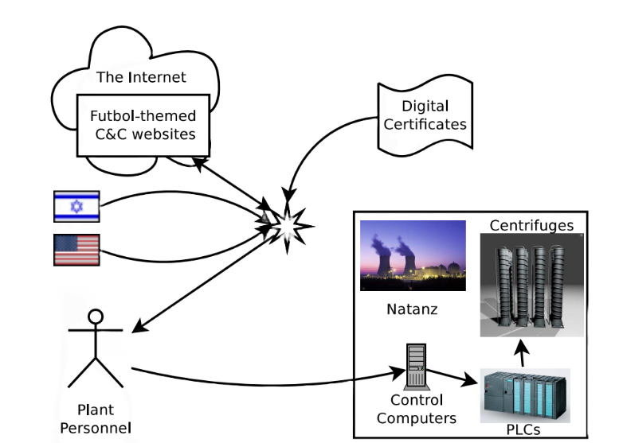

3.2.3 Rootkit Capabilities
Stuxnet features rootkit abilities in both user and kernel mode. To install the kernel-mode rootkit, it utilized digitally signed device drivers with stolen private key certificates from well-known Taiwanese manufacturers. This sophisticated method allowed Stuxnet to maintain control over infected systems without detection.

3.2.4 Targeting PLCs
Once it successfully infiltrated the target infrastructure, Stuxnet specifically aimed at the Programmable Logic Controllers (PLCs) controlling the centrifuges used for uranium enrichment. By varying the rotation speeds of the centrifuges during operation, Stuxnet caused significant damage and rendered them inoperable within a short timeframe.

3.2.5 Communication and Updates
Stuxnet was designed to communicate with other infected machines and command and control (C&C) servers located in Denmark and Malaysia. This functionality allowed it to update itself and transmit data regarding its findings, further enhancing its capabilities and effectiveness.

3.3 Target
Stuxnet was developed by the intelligence agencies of the United States and Israel to sabotage Iran’s nuclear enrichment program at the Natanz facility. Its development likely began in 2005 under the classified "Operation Olympic Games," aimed at providing a nonviolent alternative to military strikes on Iran's nuclear capabilities. The worm was specifically programmed to target the facility’s centrifuges, arranged in groups of 164—an intentional design reflecting their configuration. Stuxnet exploited the vulnerabilities of Iran’s outdated IR-1 centrifuges, known for their inefficiency and fragility, causing damage through abrupt speed changes.

3.3.1 Origin
Since the Natanz facility operates on an air-gapped network without internet connections, Stuxnet was likely introduced via a removable USB drive, indicating that the worm's creators needed human assistance to infect the system. Although neither government has officially confirmed their involvement, a 2011 video celebrating Israeli Defense Forces head Gabi Ashkenazi listed Stuxnet as a notable achievement.

4. Effects
This section examines the effects of the Stuxnet attack, focusing on its social, economic, technological, and international impacts.

4.1 Social and Political Effects
Stuxnet undermined the Iranian government’s credibility by exposing its failure to secure vital nuclear facilities. Initially, authorities minimized the attack, blaming Western nations, but later acknowledged its extent, revealing indecision and weakening public confidence in their cybersecurity. The attack was designed to avoid collateral damage, preventing escalation of conflict.

4.2 Economic Effects
The attack strained Iran's economy, exacerbated by international sanctions that limited access to nuclear technology. Damage to around 1,000 centrifuges increased pressure on resources and productivity, leading to inefficiencies in uranium enrichment. Recovery from Stuxnet's impact took approximately a year, requiring investment in enhanced security measures.

4.3 Technological Effects
Stuxnet’s primary outcome was the operational damage to centrifuges, which it manipulated while disguising the changes from operators. This highlighted vulnerabilities in industrial control systems, prompting swift action from tech companies like Microsoft and Siemens, which issued patches for the exploited flaws. The attack also instilled a lasting caution within Iranian facilities, where any technical issue is now suspected to be a cyber threat.

5. Conclusion
Stuxnet marked a pivotal moment in cybersecurity, demonstrating for the first time how malware could inflict physical damage on critical infrastructure. Jointly developed by the United States and Israel, Stuxnet targeted Iran’s nuclear facilities by exploiting zero-day vulnerabilities and bypassing air-gapped defenses. Its sophistication and success highlighted the vulnerabilities of industrial control systems globally, raising concerns about the potential for future cyberattacks. The worm’s legacy extends beyond Iran, reshaping how nations and industries defend against cyber threats. Stuxnet continues to influence cybersecurity strategies, emphasizing the need for stronger defenses, particularly in critical infrastructure, as cyberwarfare becomes an ever-growing concern.

6. Recommendation
To guard against future attacks by the Stuxnet worm, both governments and industries should adopt the following measures:
- Enhance ICS Security
- Improve Cyber Hygiene
- Promote Global Collaboration
- Secure Operational Technology
- Prepare for Future Threats

7. References

Fruhlinger, J. (2022, August 31). Stuxnet explained: The first known cyberweapon. CSO Online. https://www.csoonline.com/article/562691/stuxnet-explained-the-first-known-cyberweapon.html
Cluley, G., & Cluley, G. (2024, January 15). Stuxnet: The malware that cost a billion dollars to develop? Graham Cluley. https://grahamcluley.com/stuxnet-the-malware-that-cost-a-billion dollars/#:~:text=It's%20not%20news%20that%20the,against%20North%20Korea's%20nuclear%20weapons
Baezner, M., & Robin, P. (2018). Stuxnet. ResearchGate. https://www.researchgate.net/publication/323199431_Stuxnet
Mueller, P., & Yadegari, B. (n.d.). The Stuxnet worm. https://www2.cs.arizona.edu/~collberg/Teaching/466-566/2013/Resources/presentations/2012/topic9-final/report.pdf

