Alfred Zhang Soﬁa Bautista Tabitha Bruins Sheng Wu
Surrey Art Gallery
Association
Week 11: Two Concept Presentation



SAGA Artist © Scarlet Black

Design Focus
Communication

Internal External

To enable volunteers and members to communicate more eﬃciently with board members and coordinators for events and opportunities.
To communicate to a wider audience of art practitioners and enthusiasts to promote and generate more funds for SAGA.

Design Focus: Communication

Internal
To enable volunteers and members to communicate more eﬃciently with board members and coordinators for events and opportunities.
External
To communicate to a wider audience of art practitioners and enthusiasts to promote and generate more funds for SAGA.

Volunteer Public
Artist Business

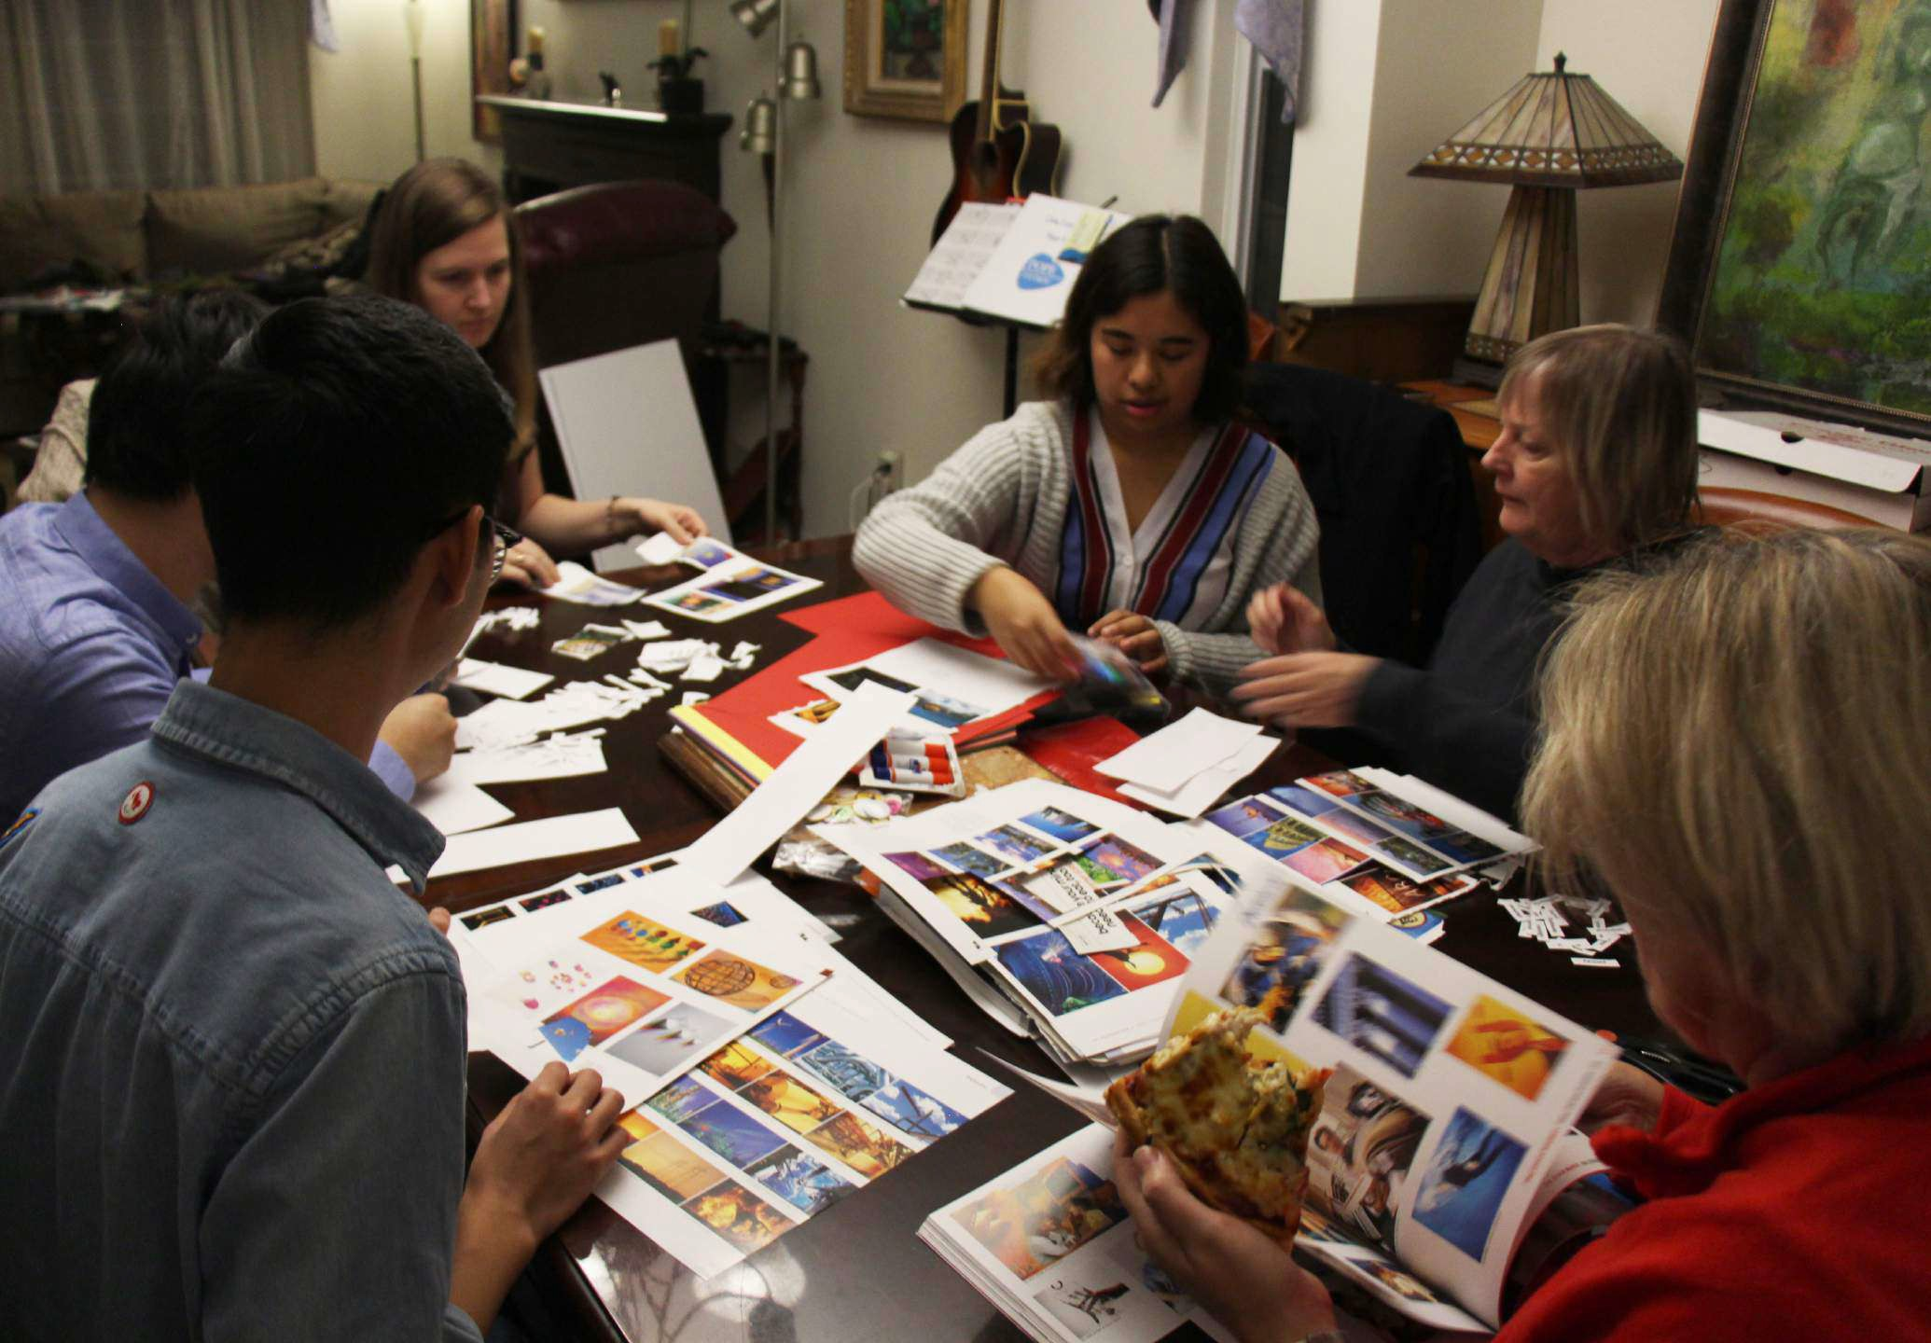
Design Focus: Communication

Internal

To enable volunteers and members to communicate more eﬃciently with board members and coordinators for events and opportunities.

Volunteer Artist
- young
- need mentorship
- less experienced
- ﬁne art


Design Focus: Communication

External
To communicate to a wider audience of art practitioners and enthusiasts to promote and generate more funds for SAGA.

Public Business
- established
- relatively bigger
- interested in art
- like to support



Artist
- young
- need mentorship
- less experienced
- ﬁne art


Concept 01
studio primer

Artist
- young
- need mentorship
- less experienced
- ﬁne art

Onboarding Programs Goals

Concept 01
studio primer

Young artist struggle ﬁnding resources online

Learn about SAGA program And discover Studio Primer

Artist
- young
- need mentorship
- less experienced
- ﬁne art

Onboarding Programs Goals


Concept 01
studio primer
“Process” challenge

Manage your proﬁles online
Remain connected through mobile

sign up for meet-up events

Artist
- young
- need mentorship
- less experienced
- ﬁne art

Onboarding Programs Goals

Concept 01
studio primer

Young artist became a better agent for their own work


Business
- established
- relatively bigger
- interested in art
- like to support

Concept 02
open gallery

This journey framework follows a mom that is attending a theatre show her daughter is in at the Surrey Art Gallery and encounters SAGA’s art rental program by accident after the show. She runs a home business as a
BUSINESS
family counsellor and is looking to decorate her patient waiting room.

JOURNEY FRAMEWORK

STAGES
Discovery
Browse
Selection
Purchase
Retention
Within 1-3 business I receive an email from SAGA that my artwork is en-route to my home address.

I’m excited to get my artwork, but don’t know how to hang or maintain it, so I book an appointment with a SAGA volunteer through a “Need Help?” link in the email.

I don’t like the piece I selected, so I look through the
I encounter the Art Rental hallway and see
artwork I am interested in learning about, but the gift shop is closed.
I look at the artwork’s product listing. I look through the sample images, but want to see how it would look in my patient room. I click
on “View in another environment”.
I am presented a list of room types and
select the “Oﬃce” category and ﬁnd a room
that looks like a patient room.
I navigate to “Browse Our Art” in the menu. I see a list of artwork for rent or purchase.
The art is projected onto my patient room image and even looks like it was hung. I like how it looks so I decide to rent it.
I am brought to the openGallery homepage and see featured art for display.
I am prompted to join SAGA’s membership program before I am able to rent out the artwork. I ﬁll and submit the membership form. After submitting it, I return to completing the rental application.
I complete the rental application and receive a conﬁrmation email with a receipt of my new business membership.
The day my artwork arrives a SAGA volunteer visits my home to help me hang it. I am pleased with the experience, as they also answer my questions about maintenance and returning the artwork.

ACTIONS
I encounter the Art Rental hallway and see artwork I am interested in learning about, but the gift shop is closed.
I see an advertisement about accessing openGallery to view more art after hours.
I look up “SAGA openGallery” on my smartphone and ﬁnd the webpage.

selection again.
(repeats n times until desired piece is found)

Is this hallway part of an exhibit?

THINKING

Where can I ﬁnd the paintings on the display?
How much paintings does SAGA have available for rent or purchase?

Who can I ask if I am interested in artwork that is currently being rented out?
What options do I have for frames?

How would this make my patients feel?
Why do I have to become a member before renting artwork?

Can I cancel my rental or membership application if I change my mind?
How long will it take for the artwork to arrive?

Who can I talk to about bulk renting artwork for the rest of my oﬃce?

Attract gallery visitors uninformed about SAGA.

SAGA’S GOALS

Make art accessible and exciting for everyone, including visitors.
Share and advertise artwork by SAGA artists to the general public.
Ensure that the user of the website receives a personalized experience.
Persuade the visitor to sign-up for a SAGA membership.
Ensure that newly-joined business members know that they are appreciated and supported.

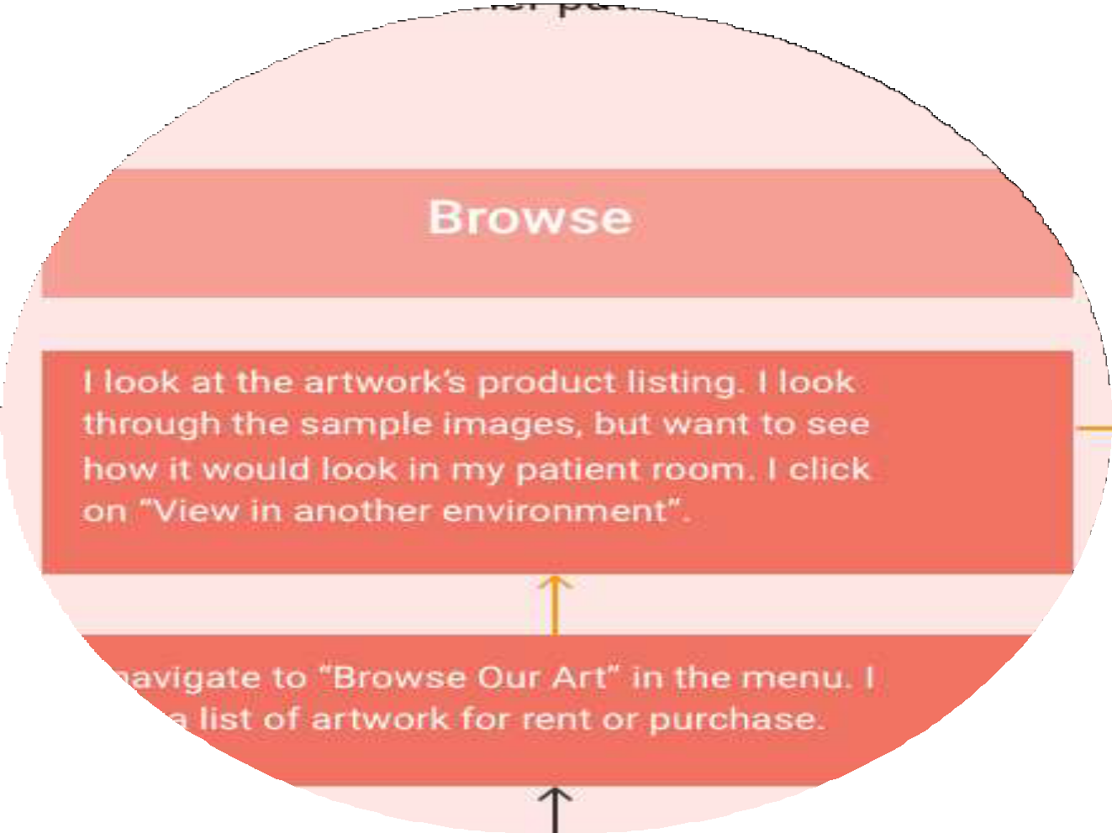This journey framework follows a mom that is attending a theatre show her daughter is in at the Surrey Art Gallery and encounters SAGA’s art rental program by accident after the show. She runs a home business as a
BUSINESS
family counsellor and is looking to decorate her patient waiting room.

JOURNEY FRAMEWORK

Discovery Browse Selection
Retention
Purchase
STAGES

I encounter the Art Rental hallway and see artwork I am interested in learning about, but the gift shop is closed.

ACTIONS
I look at the artwork’s product listing. I look
through the sample images, but want to see
how it would look in my patient room. I click on “View in another environment”.
I see an advertisement about accessing openGallery to view more art after hours.

I navigate to “Browse Our Art” in the menu. I see a list of artwork for rent or purchase.

I am presented a list of room types and select the “Oﬃce” category and ﬁnd a room that looks like a patient room.

The art is projected onto my patient room image and even looks like it was hung. I like how it looks so I decide to rent it.
I’m excited to get my artwork, but don’t know how to hang or maintain it, so I book an appointment with a SAGA volunteer through a “Need Help?” link in the email.
I am prompted to join SAGA’s membership program before I am able to rent out the artwork. I ﬁll and submit the membership form. After submitting it, I return to completing the rental application.
Within 1-3 business I receive an email from SAGA that my artwork is en-route to my home address.
I complete the rental application and receive a conﬁrmation email with a receipt of my new business membership.

I am brought to the openGallery homepage and see featured art for display.
I encounter the Art Rental hallway and see
artwork I am interested in learning about, but the gift shop is closed.
I look up “SAGA openGallery” on my smartphone and ﬁnd the webpage.
I don’t like the piece I selected, so I look through the
selection again.
The day my artwork arrives a SAGA volunteer visits my home to help me hang it. I am pleased with the experience, as they also answer my questions about maintenance and returning the artwork.
(repeats n times until desired piece is found)

Is this hallway part of an exhibit?

THINKING

Where can I ﬁnd the paintings on the display?
How much paintings does SAGA have available for rent or purchase?

Who can I ask if I am interested in artwork that is currently being rented out?
What options do I have for frames?

How would this make my patients feel?
Why do I have to become a member before renting artwork?

Can I cancel my rental or membership application if I change my mind?
How long will it take for the artwork to arrive?

Who can I talk to about bulk renting artwork for the rest of my oﬃce?

Attract gallery visitors uninformed about SAGA.

SAGA’S GOALS

Make art accessible and exciting for everyone, including visitors.
Share and advertise artwork by SAGA artists to the general public.
Ensure that the user of the website receives a personalized experience.
Persuade the visitor to sign-up for a SAGA membership.
Ensure that newly-joined business members know that they are appreciated and supported.

Business
- established
- relatively bigger
- interested in art
- like to support

Concept 02
open gallery

This journey framework follows a mom that is attending a theatre show her daughter is in at the Surrey Art Gallery and encounters SAGA’s art rental program by accident after the show. She runs a home business as a
BUSINESS
family counsellor and is looking to decorate her patient waiting room.
JOURNEY FRAMEWORK

STAGES
Discovery
Browse
Selection
Purchase
Retention
Within 1-3 business I receive an email from SAGA that my artwork is en-route to my home address.

I’m excited to get my artwork, but don’t know how to hang or maintain it, so I book an appointment with a SAGA volunteer through a “Need Help?” link in the email.

I don’t like the piece I selected, so I look through the
I encounter the Art Rental hallway and see
artwork I am interested in learning about, but the gift shop is closed.
I look at the artwork’s product listing. I look through the sample images, but want to see how it would look in my patient room. I click
on “View in another environment”.
I am presented a list of room types and
select the “Oﬃce” category and ﬁnd a room
that looks like a patient room.
I navigate to “Browse Our Art” in the menu. I see a list of artwork for rent or purchase.
The art is projected onto my patient room image and even looks like it was hung. I like how it looks so I decide to rent it.
I am brought to the openGallery homepage and see featured art for display.
I am prompted to join SAGA’s membership program before I am able to rent out the artwork. I ﬁll and submit the membership form. After submitting it, I return to completing the rental application.
I complete the rental application and receive a conﬁrmation email with a receipt of my new business membership.
The day my artwork arrives a SAGA volunteer visits my home to help me hang it. I am pleased with the experience, as they also answer my questions about maintenance and returning the artwork.

ACTIONS
I encounter the Art Rental hallway and see artwork I am interested in learning about, but the gift shop is closed.
I see an advertisement about accessing openGallery to view more art after hours.
I look up “SAGA openGallery” on my smartphone and ﬁnd the webpage.

selection again.
(repeats n times until desired piece is found)

Is this hallway part of an exhibit?

THINKING

Where can I ﬁnd the paintings on the display?
How much paintings does SAGA have available for rent or purchase?

Who can I ask if I am interested in artwork that is currently being rented out?
What options do I have for frames?

How would this make my patients feel?
Why do I have to become a member before renting artwork?

Can I cancel my rental or membership application if I change my mind?
How long will it take for the artwork to arrive?

Who can I talk to about bulk renting artwork for the rest of my oﬃce?

Attract gallery visitors uninformed about SAGA.

SAGA’S GOALS

Make art accessible and exciting for everyone, including visitors.
Share and advertise artwork by SAGA artists to the general public.
Ensure that the user of the website receives a personalized experience.
Persuade the visitor to sign-up for a SAGA membership.
Ensure that newly-joined business members know that they are appreciated and supported.

This journey framework follows a mom that is attending a theatre show her daughter is in at the Surrey Art Gallery and encounters SAGA’s art rental program by accident after the show. She runs a home business as a
BUSINESS
family counsellor and is looking to decorate her patient waiting room.

JOURNEY FRAMEWORK

Purchase Retention
Discovery
Browse
Selection
STAGES

I look at the artwork’s product listing. I look

ACTIONS
I encounter the Art Rental hallway and see artwork I am interested in learning about, but the gift shop is closed.
I see an advertisement about accessing openGallery to view more art after hours.
I look up “SAGA openGallery” on my smartphone and ﬁnd the webpage.

through the sample images, but want to see
how it would look in my patient room. I click on “View in another environment”.

I navigate to “Browse Our Art” in the menu. I see a list of artwork for rent or purchase.

I am brought to the openGallery homepage and see featured art for display.

I am presented a list of room types and select the “Oﬃce” category and ﬁnd a room that looks like a patient room.

The art is projected onto my patient room image and even looks like it was hung. I like how it looks so I decide to rent it.

I don’t like the piece I selected, so I look through the
selection again.
(repeats n times until desired piece is found)
I complete the rental application and receive a conﬁrmation email with a receipt of my new business membership.

I am prompted to join SAGA’s membership program before I am able to rent out the artwork. I ﬁll and submit the membership form. After submitting it, I return to completing the rental application.
I encounter the Art Rental hallway and see
artwork I am interested in learning about, but the gift shop is closed.
Within 1-3 business I receive an email from SAGA that my artwork is en-route to my home address.

I’m excited to get my artwork, but don’t know how to hang or maintain it, so I book an appointment with a SAGA volunteer through a “Need Help?” link in the email.

The day my artwork arrives a SAGA volunteer visits my home to help me hang it. I am pleased with the experience, as they also answer my questions about maintenance and returning the artwork.

Is this hallway part of an exhibit?

THINKING

Where can I ﬁnd the paintings on the display?
How much paintings does SAGA have available for rent or purchase?

Who can I ask if I am interested in artwork that is currently being rented out?
What options do I have for frames?

How would this make my patients feel?
Why do I have to become a member before renting artwork?

Can I cancel my rental or membership application if I change my mind?
How long will it take for the artwork to arrive?

Who can I talk to about bulk renting artwork for the rest of my oﬃce?

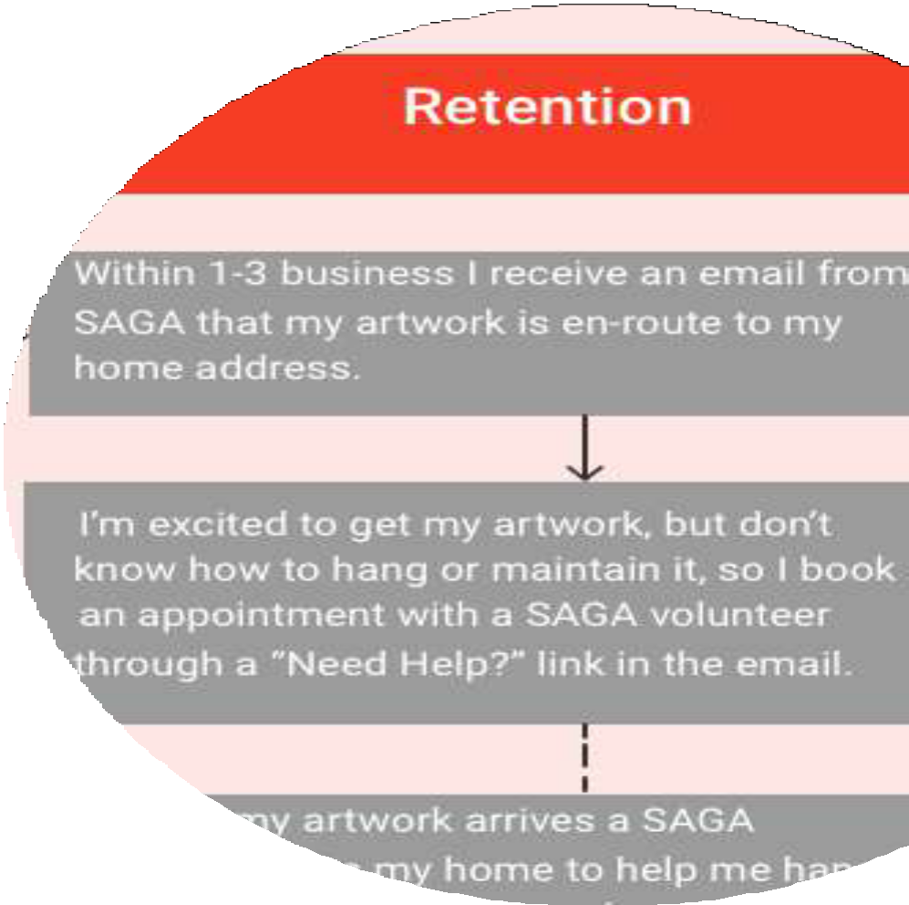Attract gallery visitors uninformed about SAGA.

SAGA’S GOALS

Make art accessible and exciting for everyone, including visitors.
Share and advertise artwork by SAGA artists to the general public.
Ensure that the user of the website receives a personalized experience.
Persuade the visitor to sign-up for a SAGA membership.
Ensure that newly-joined business members know that they are appreciated and supported.

Business
- established
- relatively bigger
- interested in art
- like to support

Concept 02
open gallery



Thank you

SAGA Artist © Audrey Bakewell

