solar HR CONSULTANCY
616, Ascon House Salah Al Din Road Deira, Dubai, UAE.
Telephone: +971-4-2695760 Email: info@solarhrm.ae Website: www.solarhrm.ae
Solar HR Management Pvt. Ltd.
- A, 1st Floor, Near SBI Zakir Nagar (West) New Friends Colony
New Delhi – 110025, India. Telephone: +91-11-2698 9999 Email: info@solarhrm.com Website: www.solarhrm.com

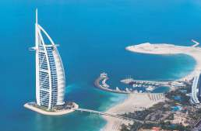

HR CONSULTANCY
HR Services Redefined

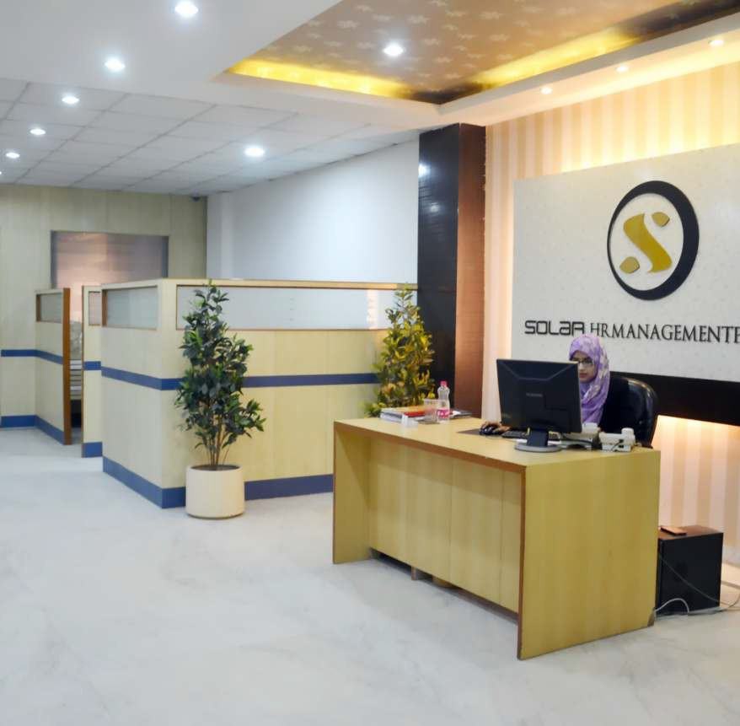

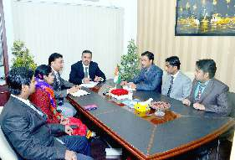
ABOUT US

olar HR Consultancy, is a division of Solar HR Management Pvt. Ltd., Approved by Ministry of Foreign Affairs, United Arab Emirates.

The management of Solar HR Consultancy has in-depth knowledge and experiences in each and every aspect of Human Resource Management and development, where client satisfaction is our top most priority.

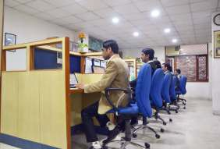
We at Solar HR Consultancy believe that our client both employers and employees are central to our services. They need to be supported at every stage of our services to them believe that each individual has its own special strength and potential to grow. Our Endeavor is to identify them with utmost sincerity and honesty.

VALUES

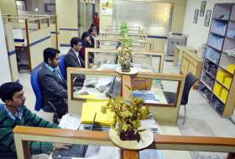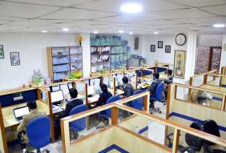

solar
Holidays
Pvt. Ltd.

HR CONSULTANCY
DUBAI

HR Management Pvt. Ltd.

Solar
Group of Companies
Integrity:
We embrace and uphold the highest standards of personal and professional ethics, honesty and trust. Because we stand for passion, performance and probity in business.

Respect:
We treat everyone with uncompromising respect, civility and fairness.

Empowerment:
We are empowered to deliver operational excellence through innovation and leadership at all levels.

Responsibility:
We are responsible to fulfill our commitments to colleague and clients with a clear understanding of the urgency and accountability inherent in those commitments.

Mission:
To develop a quality and innovative recruitment solution that is driven by passion and focused on the needs of our Clients and job Seekers.

Vision:
Solar HR Consultancy endeavors to redefine HR-Services and create a win-win situation for its Clients –the Employers & the Employees, by supporting them to excel in their pursuit, appreciating the individual potential and respecting humanity







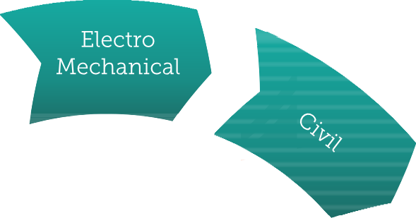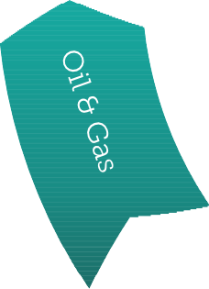We have had the opportunity to work with varied industries around the globe.
WE SERVE

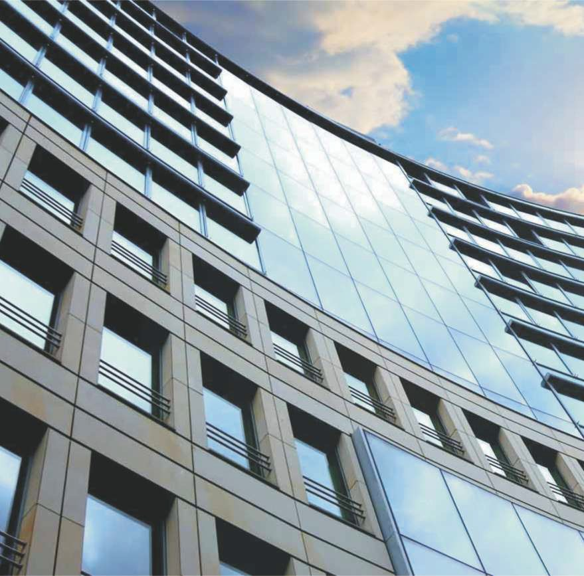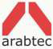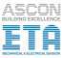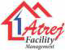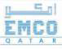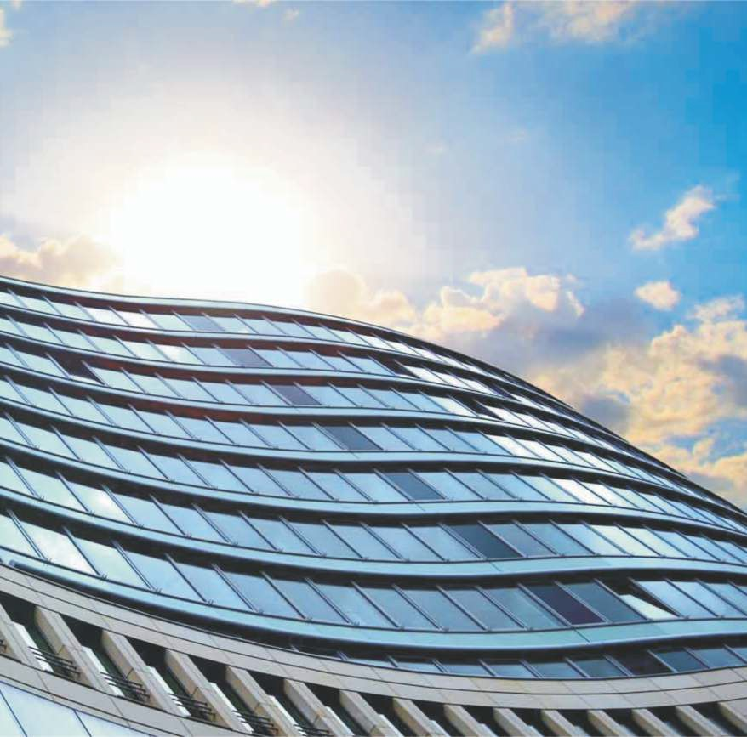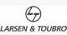

OUR CLIENTS
Our Clients are our Assets, We are glad to have work with many world class companies throughout journey. It has been a wonderful and enriching experience for us.

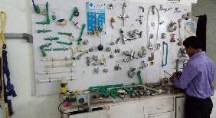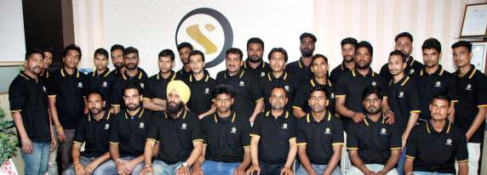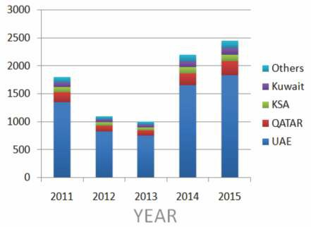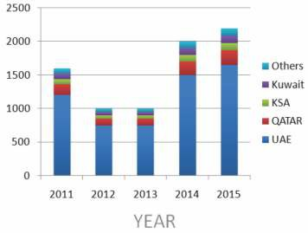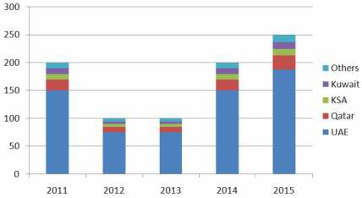 DEPLOYMENTS
In last five year we have taken a giant leap in placement of number of candidates to all GCC countries and still counting. The graph depicts our growth story in terms of numbers.

Total Number of Deployments in last 5 years

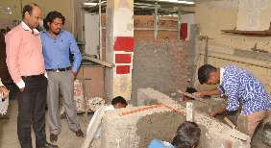

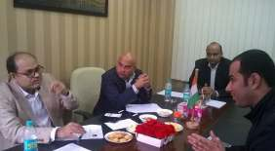
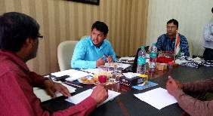
Total Number of Deployments of Workers in last 5 years
Total Number of Deployments of Senior Staff in last 5 years

Solar
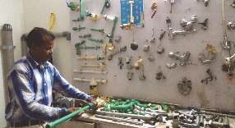
ACROSS THE GLOBE

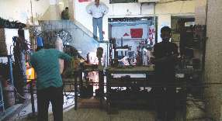
WORLD

INDIA

We are privileged to enjoy a vast and robust network across the world. Our network consist of own franchisee based training centers, trade test centers & educational institutes. Our extensive network definitely gives us an edge to meet scalability and quality to match any requirement of our esteemed client.

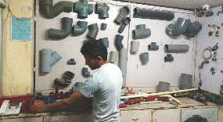
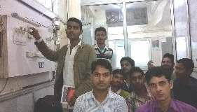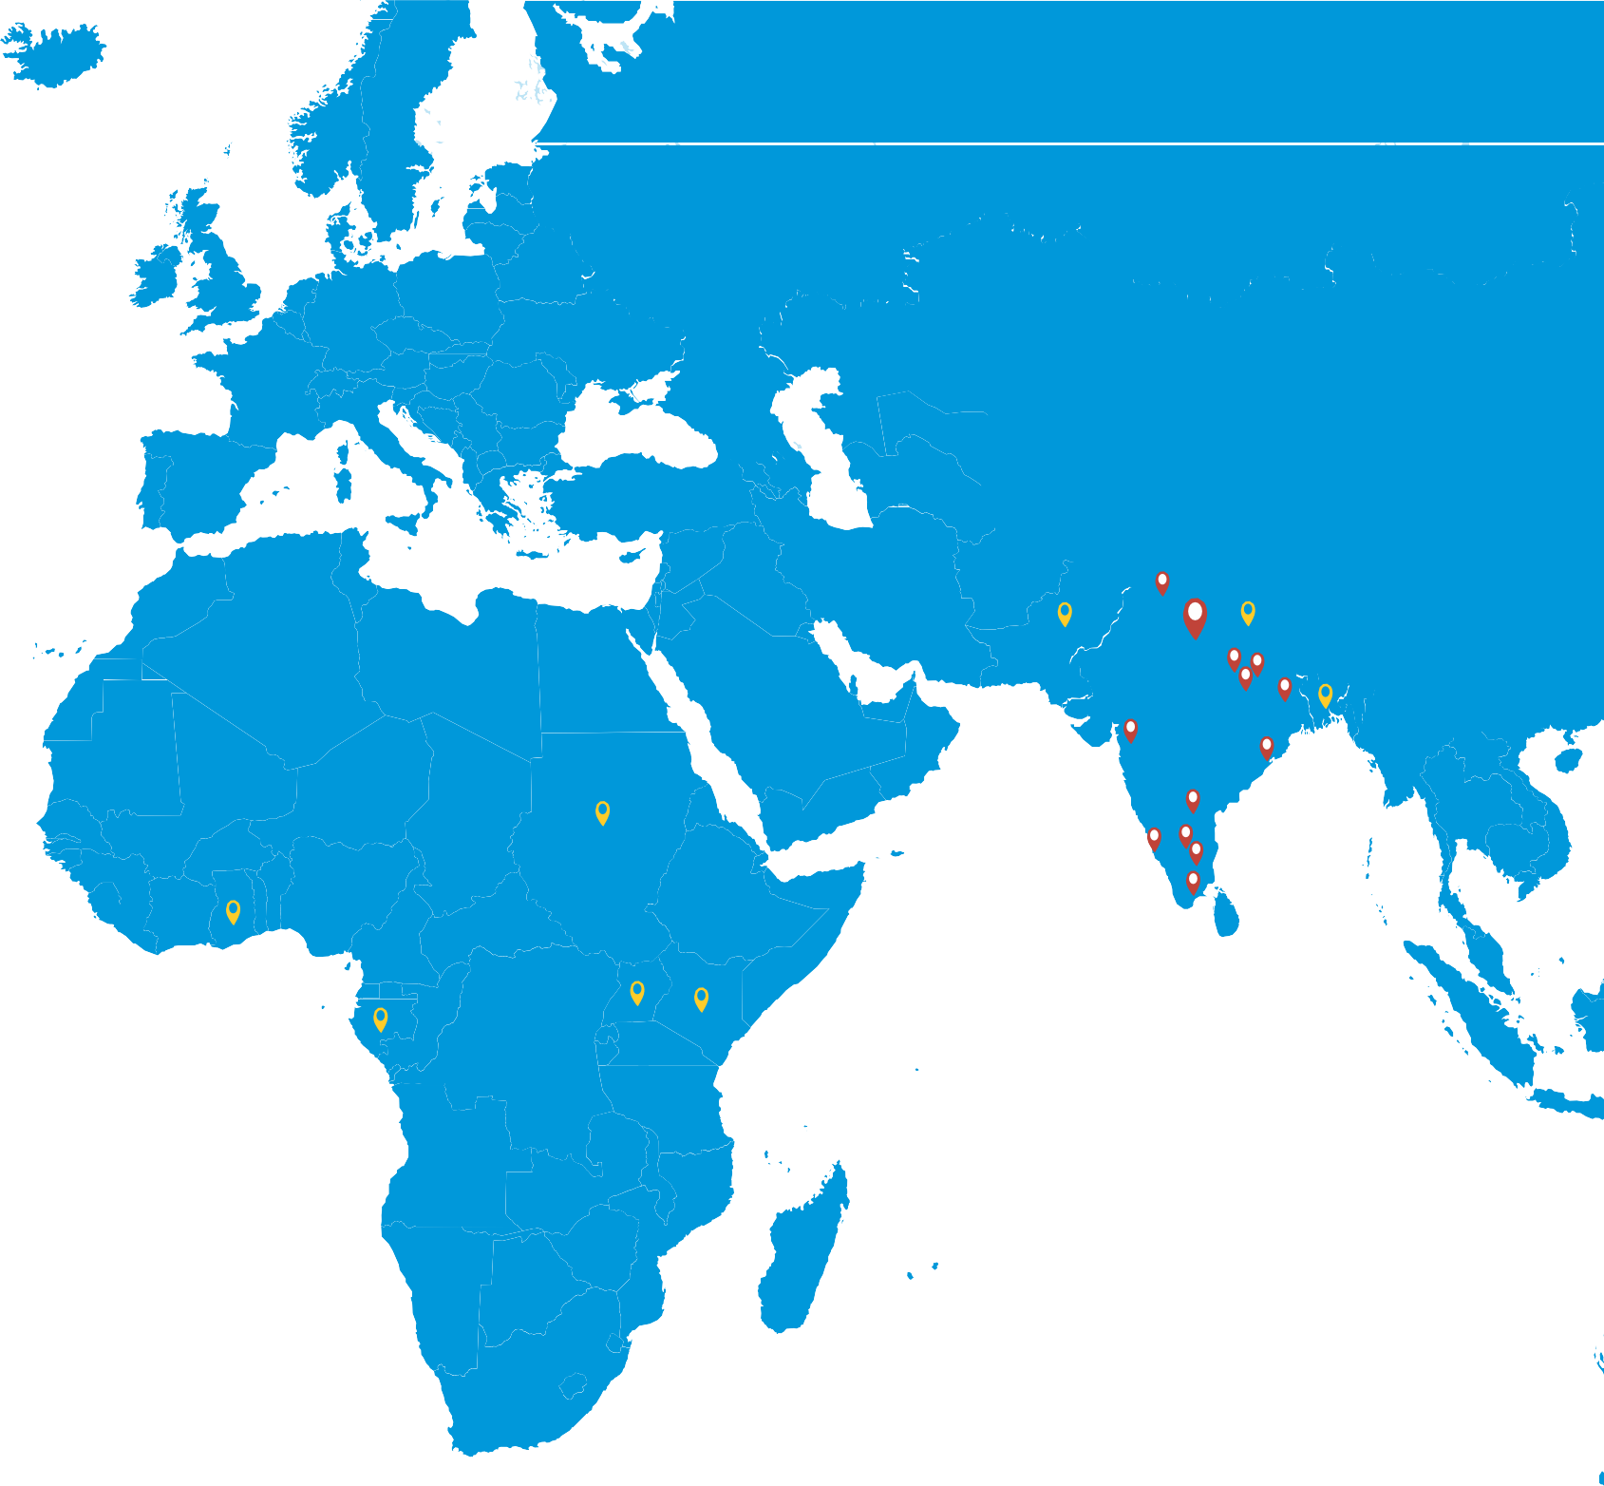UAE
Cameroon Ghana Kenya Uganda Sudan Nepal Bangladesh Pakistan
New Delhi Lucknow Gorakhpur Mairwa Muzaffarpur Cuttack Hyderabad Bangalore
Muthupet Chennai Nagapattinam Ramanathapuram Madurai Hoshiarpur Mangalore

 OTHER SERVICES
We offer a host of services which includes Visa facilities, document attestation, Tour Operating Services, Airline Ticketing Services, Rail Ticketing Services, Passport & Visa Services, Travel Insurance Services, Cruise Services, Hotel Booking Services, CAR & Coach Rental Services and Event Organizing Services.

TRAVEL INSURANCE
We as an expert recommend to all traveler to cover the risk involved in losing personal belongings and your health while travailing.


VISA CONSULTATION
Solar Holidays is India’s leading Visa Facilities Company with an expertise to handle all types of visas for individual traveler, travel agents, travel management companies and corporate.


CAR RENTALS / HOTEL RESERVATION
Reliable and proper accommodation while touring anywhere in the world is next hurdle often waste of time of customer. But we efficiently stand able to serve you which you with tailor made accommodation according to your budget.

ATTESTATION & AUTHENTICATION
We can assist you in the entire process of legalization documents.

POE & ECNR SERVICES
We facilities the temporary suspension of Emigration from POE services required by the overseas Indian Affairs, Govt. of India, for out bond


FRRO
  - Registration
  - Visa Extensions
  - PIO Card (Person of Indian Origin)
  - OCI Card(Overseas Citizen of India)

TOURS & TRAVELS
At Solar Holidays, we understand your various travelling expectation and accordingly we are offering attractive tour packages along with host of travel services to make sure you have the most fulfilling time while travelling with us.

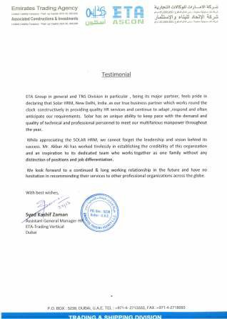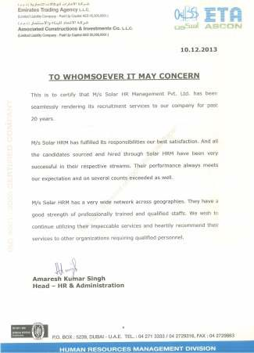 TESTIMONIAL
We have been working with Solar HR Consultancy for over two decades and their services are always been excellent. Their understanding of business need and culture of the organization enable them to provide us with the higher caliber applicants. They have always been professional, honest and reliable and I would not hesitate in recommending Solar HR Consultancy to anyone.
PR Srinivasan
DGM TECHNICAL Training (MLSS)
My experiences with Solar HR Consultancy are all positive so far. They manage expectations very well and their client services support is honest, professional and always proactive. Please, please keep it up. They are a manpower supplier that never fails to deliver and will not let you down.
Abdullah
Manager HR & Admin (ETA Zenath)


We have partnered with Solar HR Consultancy consistently over the past 20 years, and find them to be professional and easy to work with them. They have demonstrated the ability to find us the candidates that not only meet our job requirements, but also flourish within our corporate environment. We wish to recommend their services to all corporate.
Solar HR Consultancy strives to truly partner with their clients to ensure needs and expectation are met with a strong focus on a successful placement and managing candidates respectfully and professionally. This firm has surprised me with their outstanding level of service and relationship skills. It has been a stress free and enjoyable experience. I cannot recall the last time in my career where a recruiting firm has made such a positive impact. The service from start to finish is great, and I would highly recommend Solar HR Consultancy.
Ahmad Kaamil
AGM-HR (Ascon)
Senthil Kumar
Project Manager-MEP (S&T Co. LLC)

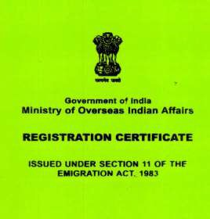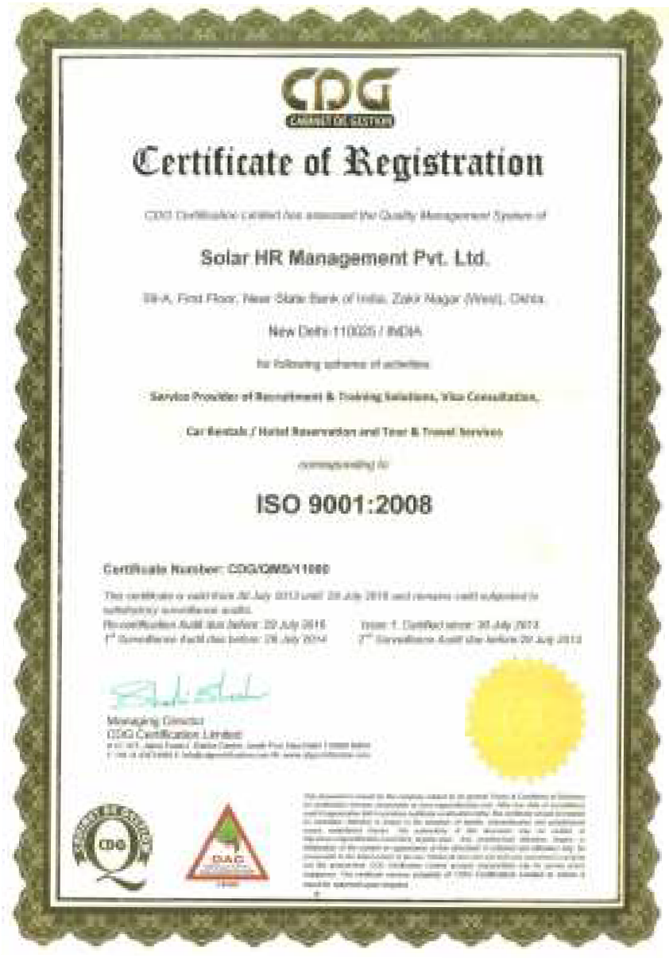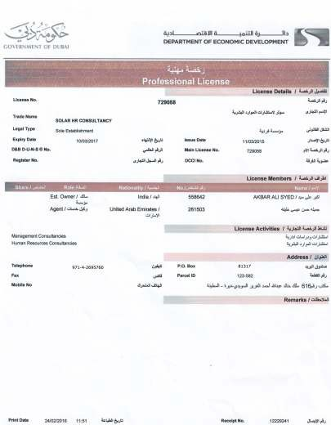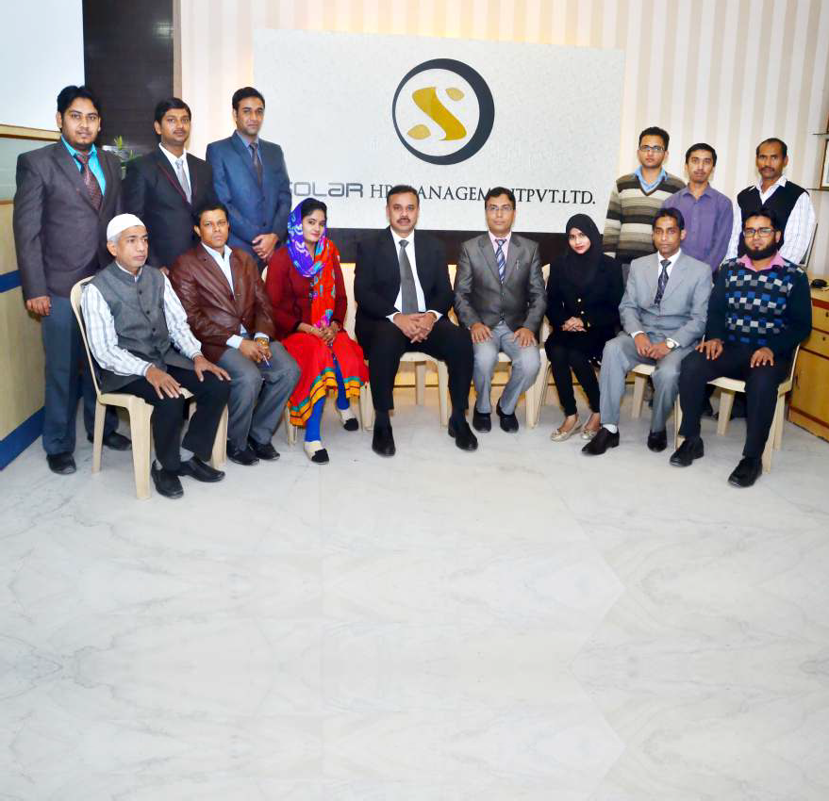

WHY SOLAR GROUP IS ONE OF THE BEST

World class infrastructure Highly qualified and experience staff
Very friendly healthy environment Strive for overall development of all category
Onsite training for workers Strategically located for more convenience

CERTIFICATION
We are committed to quality through integrity client focus, innovation team work and ethical business practice. We shall strive hard to meet the international standards in respect of quality Human resources to the satisfaction of our patrons.

