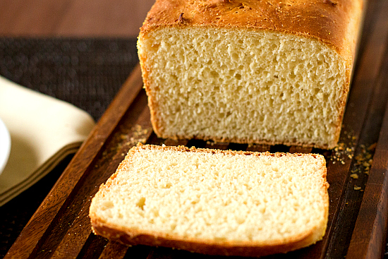
English Muffin Bread ~ adapted from Cooks Country

Cornmeal
5 cups bread flour
4 ½ tsp instant or rapid rise yeast
1 tbsp sugar
2 tsp salt
1 tsp baking soda
3 cups whole milk, heated to 120 degrees.

1. Grease two 8 1/2 by 4 1/2 inch loaf tin and dust with cornmeal. Combine flour, yeast, sugar, salt and baking soda in a large bowl. Stir in hot milk until combined and dough pulls away from sides of bowl, about 1 min. Cover dough with greased plastic wrap and let rise in warm place for 30 min., or until dough is bubbly and has doubled in size.

2. Stir dough and divide between prepared loaf pans, pushing into corners with greased rubber spatula. (Pans should be about two-thirds full.) Cover pans with greased plastic and let dough rise in warm place until it reaches edges of pans, about 30 mins. Adjust oven rack to middle position and heat oven to 375 degrees.

3. Discard plastic and transfer pans to oven. Bake until bread is browned and registers 200 degrees, about 30 minutes, rotating and switching pans halfway through baking. Turn bread out onto wire rack and let cool completely, about 1 hour.

