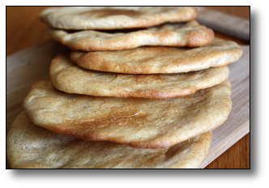
Naan
(America's Test Kitchen)

Wet ingredients:
½ cup ice cold water
⅓ cup whole fat, plain yogurt
3 tbsp vegetable oil
1 egg yolk

Dry ingredients:
2 cups bread flour (King Arthur)
½ tsp rapid rise, instant yeast
1 ¼ tsp sugar

Also:
1 ¼ tsp salt
Melted butter

Mix wet and dry ingredients separately. Mix dry ingredients in a food processor.

Run the dry ingredients on high in the processor, add the wet ingredients while the dry ingredients are being run over a 10 second period.

Let dough sit 10 minutes.

Add 1 ¼ tsp salt to dough, run to mix.

Remove, knead for 1 minute on flour-covered surface.

Move dough to an oiled mixing bowl, cover with plastic, refrigerate for 16-24 hours.

Move fermented dough onto floured surface, divide into quarters, tuck dough portions into balls, let rest for 15 minutes on a plate or baking pan.

Heat cast iron pan with 1 tbsp of oil on medium high heat. Wipe oil out with paper towel. Roll out dough balls into 9" diameter discs. Stab with fork 20+ times to prevent bubble formation. Put into pan, cook 2 minutes per side.

Brush with melted butter and serve.

