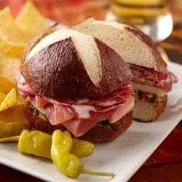
Pretzel Bread

Dough:
1 cup milk
2 tablespoons butter or margarine
2 tablespoons brown sugar
1 envelope Fleischmann's RapidRise Yeast
2 teaspoons salt
3 cups all-purpose flour, or more as needed

Boiling Solution:
3 quarts water
3/4 cup baking soda

Egg Wash:
1 egg
1 teaspoon water

Directions:
Heat milk and butter until warm (100 degrees to 110 degrees F); the butter will not completely melt. Combine with undissolved yeast and brown sugar in a large mixer bowl. Stir in salt and 2 cups flour, beat for 3 minutes. Gradually add enough remaining flour to make a soft dough. Knead on a floured surface until smooth and elastic, about 8 to 10 minutes. Place in a greased bowl, cover and let rise for 1 hour, or until doubled in size.

Preheat oven to 400 degrees F.

Combine boiling solution and bring to a boil. Punch dough down and divide into 2 equal pieces. Form each piece into a tight, smooth ball. Boil each loaf in the solution for 2 minutes, turning after 1 minute. Remove loaves from pot using a slotted spoon and place on a greased baking sheet.

Brush with egg wash and cut a cross in the top. Bake for 15 minutes then reduce the temperature to 350 degrees F and bake an additional 10 to 12 minutes until the loaves are evenly browned. Remove from pan and cool on a wire rack.

