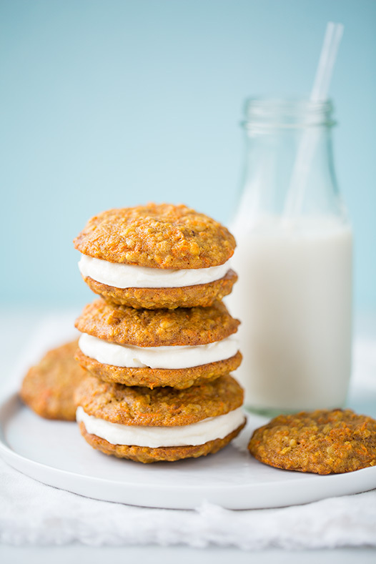
Carrot Cake Marshmallow Sandwich Cookies
For the cookies:
1 1/2 cups all-purpose flour
3/4 cup rolled oats
1 teaspoon pumpkin pie spice
1/2 teaspoon baking soda
1/2 teaspoon salt
1 1/2 sticks (12 tablespoons) unsalted butter, at room temperature
1/2 cup granulated sugar
1/4 cup packed light brown sugar
3/4 cup finely grated carrots (about 2 small)
1 large egg
1/3 cup raisins
For the filling:
1 cup marshmallow cream
4 ounces cream cheese, at room temperature
4 tablespoons unsalted butter, at room temperature
1 teaspoon pure vanilla extra

Position racks in the upper and lower thirds of the oven; preheat to 350 degrees F. Whisk the flour, oats, pumpkin pie spice, baking soda and salt in a medium bowl. Beat the butter, granulated sugar and brown sugar in a large bowl with a mixer on medium-high speed until light and fluffy, 3 to 5 minutes. Add the carrots and beat until combined, then beat in the egg. Stir in the flour mixture with a rubber spatula until combined, then stir in the raisins.
Line two baking sheets with parchment paper. Arrange 24 scoops of dough (1 rounded tablespoon per cookie) about two inches apart on the prepared baking sheets. Bake, switching the pans halfway through, until the cookies are golden and set around the edges but the centers are still soft, about 20 minutes. Transfer to racks and let cool completely on the baking sheets.
Make the filling: Beat the marshmallow cream, cream cheese, butter and vanilla in a large bowl with a mixer on medium speed until thick and fluffy, about 3 minutes. Spread 1 tablespoon filling on the flat side of half the cookies; sandwich with the remaining cookies. Store in an airtight container in the refrigerator up to 2 days; bring to room temperature before serving.
Makes 12 sandwich cookies

