Buffalo Chicken Burgers with Blue Cheese Mayo

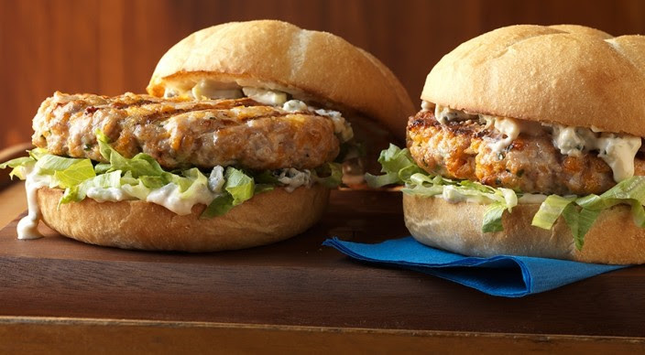
Ingredients
Mayo
- ⅓ cup mayonnaise
- ⅓ cup crumbled blue cheese
- 2 teaspoons cider vinegar
- 1 teaspoon hot pepper sauce
- ½ rib celery, cut crosswise into thin slices

Patties
- 1-¼ pounds ground chicken, preferably thigh meat
- ½ cup panko bread crumbs
- 3 tablespoons hot pepper sauce
- 2 tablespoons finely chopped fresh chives
- ½ teaspoon kosher salt
- Extra-virgin olive oil
- 4 hamburger buns, split
- 4 large leaves iceberg lettuce, thinly sliced

Instructions
- Combine the mayo ingredients, except the celery, and mash well with a fork. Stir in the celery. Cover and refrigerate until ready to use.
- Mix the patty ingredients, and then gently form four patties of equal size, each about 1 inch thick. With your thumb or the back of a spoon, make a shallow indentation about 1 inch wide in the center of the patties to prevent them from forming a dome as they cook. Refrigerate the patties until ready to grill.
- Prepare the grill for direct cooking over medium heat (350° to 450°F).
- Brush the patties with oil, and then grill over direct medium heat, with the lid closed, until fully cooked (165°F), 8 to 10 minutes, turning once. During the last 30 seconds to 1 minute of grilling time, toast the buns, cut side down, over direct heat.
- Spread the cut side of each bun with the blue cheese mayo, and then top with lettuce and a patty. Serve warm.

