Cabo Beach Burgers

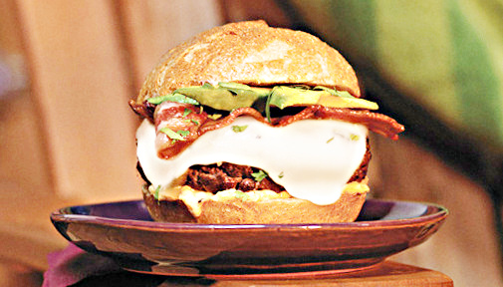

Ingredients
1 | pound lean ground beef
4 | slices bacon
4 | slices pepper jack cheese
4 | kaiser rolls, split
1/4 | cup chipotle-flavored reduced fat mayonnaise
1 | Hass avocado, cut into 12 slices
1/2 | cup coarsely chopped fresh cilantro leaves

Instructions
- Prepare the grill for direct cooking over medium-high heat (400° to 500°F).
- Shape the ground beef into 4 patties. Grill the patties over direct medium-high heat, 4 to 6 minutes on each side, or until done (160°F). Meanwhile, cook the bacon as directed on package.
- During the last minute of grilling time, place a slice of cheese on top of each patty to melt.
- Spread the rolls with mayonnaise, and then top each with a cheeseburger, a slice of bacon, avocados, and cilantro.

