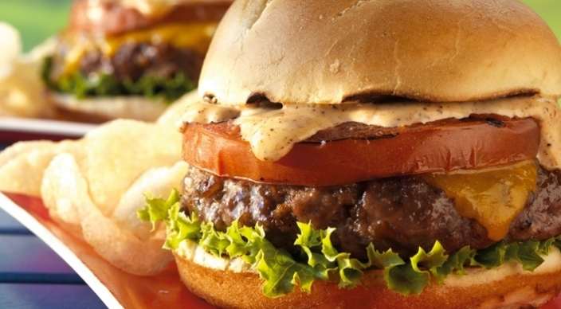
Chorizo Burgers

Sauce
- ½ cup mayonnaise
- 1 tablespoon ketchup
- ½ teaspoon fresh lemon juice
- ½ teaspoon prepared chili powder
- ¼ teaspoon chipotle chile powder
- ¼ teaspoon kosher salt

Patties
- 1¼ pounds ground chuck (80% lean)
- 6 ounces cured (not fresh) chorizo sausage, finely chopped
- 1 teaspoon granulated garlic
- ¾ teaspoon kosher salt
- ¼ teaspoon freshly ground black pepper

- 1 large beefsteak tomato, cut crosswise into 4 slices
- 2 teaspoons extra-virgin olive oil
- 4 thin slices sharp cheddar cheese
- 4 hamburger buns, split
- 4 leaves lettuce

Instructions
- Prepare the grill for direct cooking over medium-high heat (400° to 500°F).

- In a small bowl whisk the sauce ingredients.

- In a medium bowl gently mix the patty ingredients. With wet hands, form four patties of equal size, each about ¾ inch thick. Don’t compact the meat too much or the patties will be tough. With your thumb or the back of a spoon, make a shallow indentation about 1 inch wide in the center of each patty. This will help the patties cook evenly and prevent them from puffing on the grill. Brush the tomato slices on both sides with the oil.

- Brush the cooking grates clean. Grill the patties over direct medium-high heat, with the lid closed, until they are cooked to medium doneness, 8 to 10 minutes, turning once when the patties release easily from the grate without sticking. During the last 4 minutes of grilling time, grill the tomato slices over direct medium-high heat until warmed through and tender, turning once. During the last minute of grilling time, place a slice of cheese on each patty to melt and toast the buns, cut side down, over direct heat. Build each burger on a toasted bun with a patty, lettuce, grilled tomato, and sauce. Serve warm.

