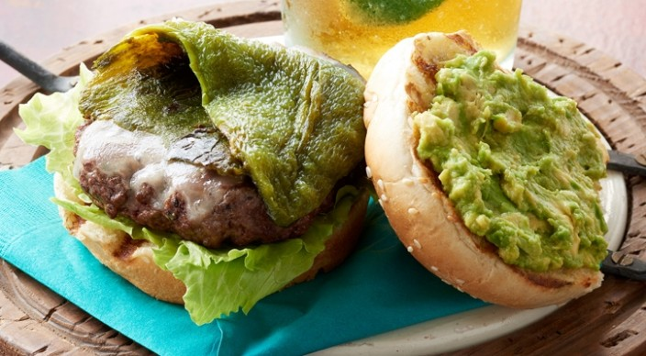
Chile Burgers

2 large poblano chile peppers
1½ pounds ground chuck (80% lean)
2 teaspoons finely chopped fresh oregano leaves or 1 teaspoon dried oregano
¼ teaspoon freshly ground black pepper
Kosher salt
4 thin slices Monterey Jack cheese
4 seeded hamburger buns, split
1 large avocado, mashed
4 leaves iceberg lettuce

Prepare the grill for direct cooking over medium-high heat (about 400°F).

Grill the poblanos over direct medium-high heat, with the lid closed, until blackened and blistered all over, about 15 minutes, turning occasionally. Place the peppers in a bowl and cover with plastic wrap to trap the steam. Let stand for 10 minutes. Remove the peppers from the bowl and discard the skin, stems, and seeds. Cut each pepper into two pieces that will fit over the patties.

In a medium bowl combine the ground chuck, oregano, pepper, and 1 teaspoon salt. Gently form four patties of equal size, each about ¾ inch thick. With your thumb or the back of a spoon, make a shallow indentation about 1 inch wide in the center of the patties to prevent them from forming a dome as they cook.

Grill the patties over direct medium-high heat, with the lid closed, until cooked to medium doneness (160°F), 8 to 10 minutes, turning once. During the last 30 seconds to 1 minute of grilling time, place a slice of cheese on each patty to melt, and toast the buns, cut side down, over direct heat.

Spread the top halves of the buns with avocado and season the avocado with salt. Build each cheeseburger with lettuce, a patty, and a piece of the poblano pepper. Serve right away.

