Balsamic-Marinated Flank Steak Sandwiches with Peppers and Onions

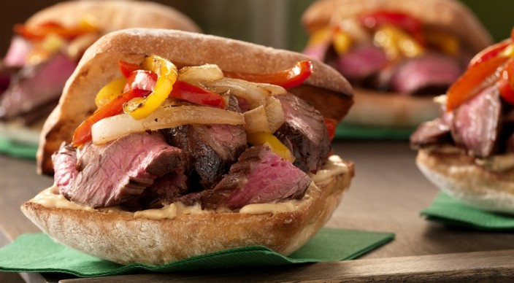
Marinade:
1/2 cup balsamic vinegar
1/4 cup extra-virgin olive oil
2 tablespoons Worcestershire sauce
1 tablespoon Dijon mustard
4 garlic cloves, minced or pushed through a press
1 teaspoon kosher salt
3/4 teaspoon freshly ground black pepper

Also:
1 flank steak, about 1 1/2 pounds and 3/4 inch thick
2 tablespoons extra-virgin olive oil
2 bell peppers, any color, cut into thin strips
1 large yellow onion, cut in half and thinly sliced
1/2 teaspoon kosher salt
1/2 teaspoon freshly ground black pepper
4 ciabatta or other soft sandwich rolls, split
4 teaspoons Dijon mustard

In a large, resealable plastic bag combine the marinade ingredients. Place the steak in the bag (cut the steak crosswise in half, if needed, to fit in the bag), press the air out of the bag, and seal tightly. Turn the bag to distribute the marinade, place in a bowl, and refrigerate for at least 4 hours or overnight, turning occasionally.

In a large skillet over medium-high heat, warm 2 tablespoons oil. Add the bell peppers, onion, salt, and pepper and cook until the vegetables begin to soften, 10 to 12 minutes, stirring occasionally. Reduce the heat to medium and cook until the vegetables are very tender and caramelized, 8 to 10 minutes more, stirring often. Remove from the heat and cover to keep warm.

Prepare the grill for direct cooking over medium heat (350° to 450°F).

Remove the steak from the bag and discard the marinade. Grill the steak over direct medium heat, with the lid closed, until cooked to your desired doneness, 8 to 12 minutes for medium rare, turning once. During the last 30 seconds to 1 minute of grilling time, toast the rolls, cut side down, over direct heat. Remove from the grill and let the steak rest for 3 to 5 minutes. Cut the steak across the grain into thin slices.

Spread 1 teaspoon mustard on the bottom half of each split roll. Build the sandwiches with the meat and the pepper-onion mixture. Serve warm.

