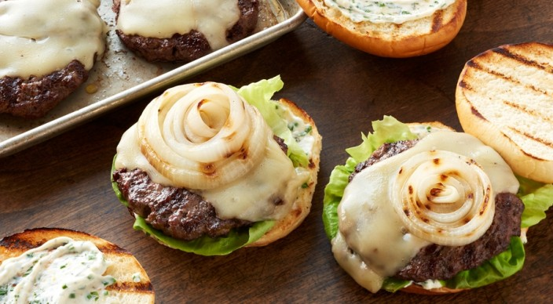
Fontina Burgers w/ Lemon-Herb Mayo

Mayo
1 cup mayonnaise
2 tablespoons finely chopped fresh chives
1 1/2 tablespoons finely chopped fresh parsley
2 teaspoons finely chopped fresh thyme leaves
2 cloves garlic, minced
1 teaspoon freshly grated lemon zest
1 teaspoon fresh lemon juice

Burger, etc.
1 1/2 pounds ground chuck (80% lean)
1 teaspoon kosher salt
1/4 teaspoon freshly ground black pepper
1 large yellow onion, cut crosswise into four 1/2-inch-thick slices
2 tablespoons extra-virgin olive oil, divided
5 ounces Fontina cheese, thinly sliced
4 Hawaiian sweet sandwich buns, or other soft sandwich buns, split
4 large leaves butter lettuce

In a small bowl whisk the mayo ingredients. Cover and refrigerate.

Mix the ground chuck, salt, and pepper, and then gently form four patties of equal size, each about ¾ inch thick. With your thumb or the back of a spoon, make a shallow indentation about 1 inch wide in the center of the patties to prevent them from forming a dome as they cook. Cover and refrigerate the patties until ready to grill.

Prepare the grill for direct cooking over medium-high heat (400° to 500°F).

Lightly brush the onion slices on both sides with oil, and brush the cut side of the buns with oil. Grill the onion slices and the patties over direct medium-high heat, with the lid closed, until the onions are lightly charred on both sides and the patties are cooked to medium doneness (160°F), 8 to 10 minutes, turning once. During the last 30 seconds to 1 minute of grilling time, place the cheese on the patties to melt, and toast the buns, cut side down, over direct heat.

Build each burger on a bun with mayo, a patty, onions, and a lettuce leaf. Serve warm.

