Green-Chile Cheeseburgers
from Cook’s Illustrated Summer Grilling 2011
3 Anaheim chiles, stemmed, halved lengthwise, and seeded
3 jalapeno chiles, stemmed, halved lengthwise, and seeded
1 onion, peeled and sliced into 1/2-inch-thick rounds
1 medium garlic clove, minced or pressed
Table salt and ground black pepper
1 1/2 pounds 85% lean ground beef
4 slices deli American cheese (or mild Cheddar)
4 hamburger buns or rolls

Light a charcoal fire until hot. Clean the grate.
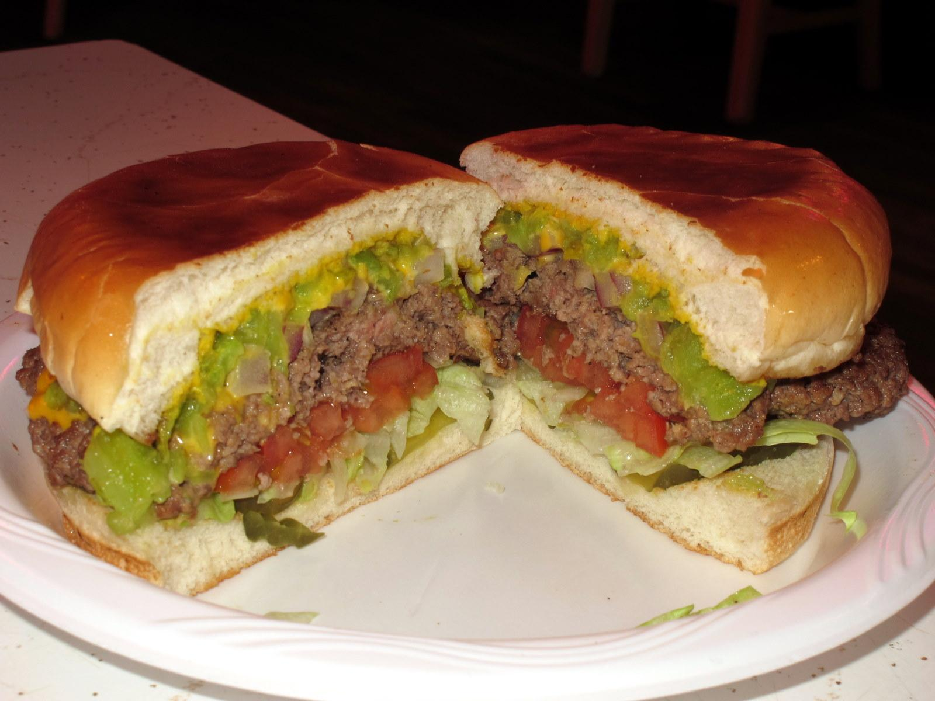
Grill the chiles and onion until charred and tender, 2-4 minutes per side. Remove the charred skin from the chiles and separate the onion into rings. Put the chiles, onion and garlic in a food processor and pulse until chopped in small chunks. Set aside all but 1/4 cup in a small bowl and season with salt and pepper to taste. Process the remaining 1/4 cup until finely chopped.
Add the finely chopped chile mixture to the ground beef along with 1/2 teaspoon salt and 1/4 teaspoon pepper and mix until well combined. Form the mixture into patties, creating an indent in the center of each.
Grill the burgers, divot side down 3-5 minutes, or until well browned. Flip the burgers. Add chopped chile mixture to each and cover with a piece of cheese. Grill for an additional 3-5 minutes.
Serve on hamburger buns with condiments.

