Grown Up Grilled Cheese
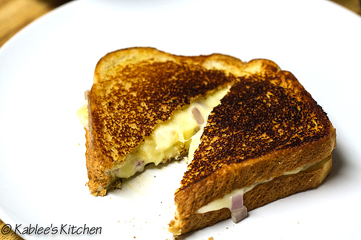
Ingredients:
7 oz aged cheddar cheese,
cut into 24 equal pieces
2 oz Brie cheese, rind removed
2 tbsp dry white wine
4 tsp minced shallot
3 tbsp unsalted butter, softened
1 tsp Dijon mustard
8 slices whole wheat bread

Directions:
1. Process cheddar, Brie, and wine in food processor until smooth paste is formed, 20 to 30 seconds. Add shallot and pulse to combine, 3 to 5 pulses. Combine butter and mustard in small bowl.

2. Divide mustard butter evenly between slices of bread. Spread butter evenly over surface of bread. Flip 4 slices of bread over and spread cheese mixture evenly over slices. Top with remaining 4 slices of bread, buttered side up.

3. Preheat 12-inch nonstick skillet over medium heat. Place 2 sandwiches in skillet, reduce heat to medium-low, and cook until both sides are crisp and golden brown, 2 minutes a side, moving sandwiches to ensure even browning. Remove sandwiches from skillet and let stand 1 minute before serving. Repeat with remaining two sandwiches.

