Spicy Jalapeno and Bacon Burgers

These are terribly hard to work with on the BBQ. Please try one egg white per pound of ground beef as a binding agent next time.
Ingredients
4 slices bacon
1 jar (12 ounces) sliced, pickled jalapeños, drained
1-1/2 pounds ground chuck (80% lean)
1 log (4 ounces) goat cheese, crumbled
1 tablespoon minced garlic
1-1/2 teaspoons kosher salt
8 thin slices pepper jack cheese
4 hamburger buns, split

Instructions
In a large skillet over medium heat, cook the bacon until crisp, 10 to 12 minutes, turning occasionally. Drain the bacon on paper towels. Roughly chop the bacon into 1/2-inch pieces.

Prepare the grill for direct cooking over medium-high heat (400° to 500°F).

Roughly chop half of the jalapeños and set aside the remaining sliced jalapeños. In a large bowl gently mix the ground chuck with the roughly chopped jalapeños, the goat cheese, the garlic, and the salt. With wet hands, gently form four loosely packed patties of equal size, each about 3/4 inch thick. Don’t compact the meat too much or the patties will be tough. Using your thumb or the back of a spoon, make a shallow indentation about 1 inch wide in the center of each patty. This will help the patties cook evenly and prevent them from puffing on the grill.

Brush the cooking grates clean. Grill the patties over direct medium-high heat, with the lid closed as much as possible, until fully cooked, 10 to 12 minutes, turning once (because these patties have so much moisture, they will not brown as much as most patties). During the last minute of grilling time, add two slices of cheese to each patty to melt and toast the buns, cut side down, over direct heat.

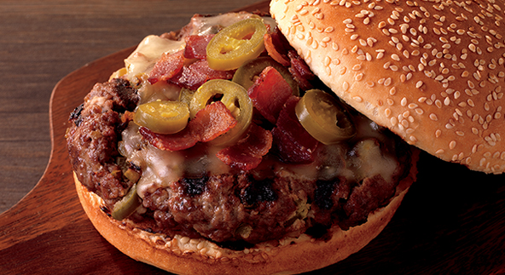
Remove the patties and buns from the grill. Place the patties on the bottom bun halves, and top them with as much of the bacon and the reserved jalapeño slices as you like. Put the top bun halves in place, and serve the burgers warm.

