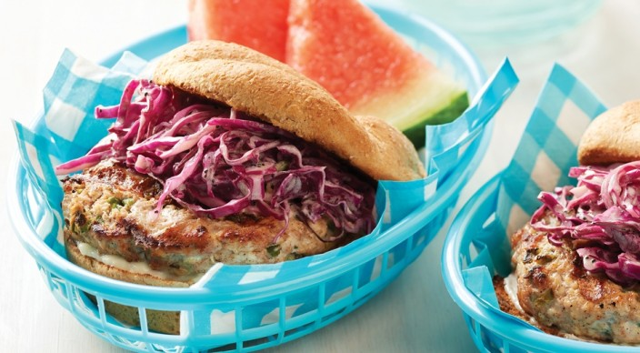
Jerk Chicken Burgers

Patties
8 ounces ground chicken thigh meat
8 ounces ground chicken breast meat
2 medium jalapeño chile peppers, finely chopped
¼ cup minced scallions (white and light green parts only)
1 tablespoon fresh lime juice
1 teaspoon ground ginger
1 teaspoon packed dark brown sugar
¾ teaspoon dried thyme
¾ teaspoon ground allspice
½ teaspoon kosher salt
½ teaspoon hot pepper sauce, or to taste

Slaw
2 tablespoons sour cream
2 tablespoons mayonnaise
1 tablespoon fresh lime juice
¼ teaspoon kosher salt
¼ teaspoon packed dark brown sugar
⅛ teaspoon freshly ground black pepper
¼ cup vegetable oil
1 teaspoon poppy seeds
4 cups thinly sliced or shredded red cabbage (about 10 ounces)
2 tablespoons minced scallions (white and light green parts only)

Vegetable oil
4 whole-wheat hamburger buns, split
Mayonnaise

Instructions
Mix the patty ingredients, and then form four patties of equal size, each about ½ inch thick. Place the patties on wax paper squares, and refrigerate until ready to grill.

In a large bowl whisk the sour cream, mayonnaise, lime juice, salt, brown sugar, and pepper. Slowly whisk in the oil until emulsified. Stir in the poppy seeds, and then add the cabbage and scallions. Toss until well coated.

Prepare the grill for direct cooking over medium heat (350° to 450°F).

Brush the tops of the patties with oil. Place the patties on the grill, wax paper side up, and peel off the wax paper. Grill the patties over direct medium heat, with the lid closed, until fully cooked (165°F), 8 to 10 minutes, turning once after 6 minutes (when the patties release easily from the cooking grates). During the last 30 seconds to 1 minute of grilling time, toast the buns, cut side down, over direct heat.

Build each burger on a bun with mayonnaise, a patty, and some slaw. Serve warm with the remaining slaw on the side.

