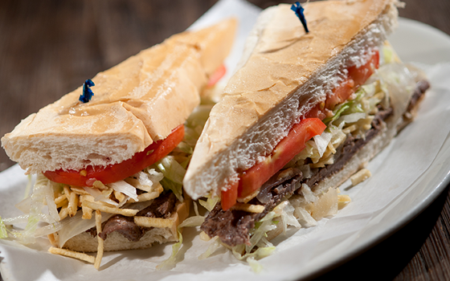
Pan con Bistec

Ingredients
- 6 - 1/2-pound Top Round Steaks
- 2 cloves Garlic (chopped)
- 3 tablespoons Olive Oil
- 1 tablespoon Butter
- Juice of 2 Limes
- 1 medium Onion (finely chopped)
- 3 tablespoons Parsley (finely chopped)
- Salt and Pepper
- 6 small Cuban Loafs (sliced in half)

Pound steaks on both sides until super thin. Place steaks in a shallow dish. Season with the salt, pepper, garlic, lime and marinate for about an hour.

Remove steaks from marinade, reserving the marinade. In a skillet over high heat, add the oil and once hot, brown the steaks, about 2 minutes per side. Remove steaks and set aside. In the same pan, add the marinade, onion and pat of butter, and cook until the onions soften.

Trim the steak to the bread, if necessary. Place the steaks, marinade and parsley on a loaf of cuban bread and serve with a mojito or Cuba Libre.

