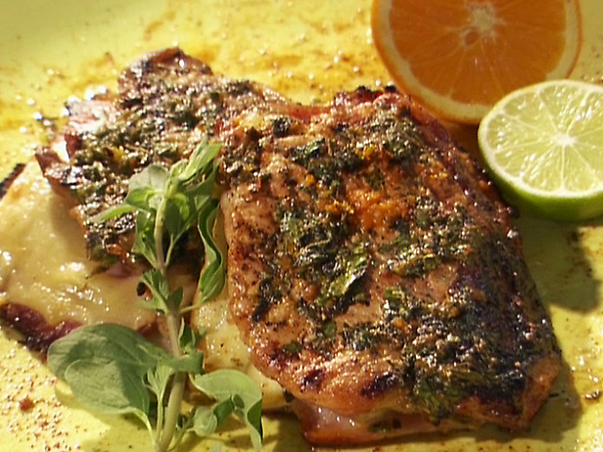
Cuban-Style Pork Chop
Sandwiches

Ingredients
3/4 cup fresh orange juice
1/2 cup fresh lime juice
1/3 cup coarsely chopped fresh oregano leaves
6 cloves garlic, coarsely chopped
1 teaspoon ground cumin
1/4 cup canola oil

4 (8-ounce) pork chops, butterflied and thinly pounded
Salt and freshly ground black pepper

8 (1/4-inch) thick slices Swiss cheese
8 (1/4-inch) thick slices boiled ham
2 sour dill pickles, thinly sliced (need about 16 slices)
2 tablespoons chopped cilantro leaves
1/4 cup olive oil

Directions
Heat the grill to high.

Whisk together 1/2 cup orange juice, 1/4 cup lime juice, 3 tablespoons oregano, the garlic, cumin, and canola oil in a large baking dish. Add the pork and turn to coat. Cover and let marinate for at least 15 minutes and up to 2 hours in the refrigerator.

Remove the pork from the marinade and pat dry. Place the chops on a flat surface, cut-side up and season with salt and pepper.

Place 1 slice of cheese, 2 slices of ham, a few slices of pickle and another slice of cheese on 1 half of the chop. Fold over brush the top with oil and season with salt and pepper. Repeat with remaining ingredients. Place the chops on the grill, oil side down and grill until golden brown, 3 to 4 minutes. Flip the chops over and continue grilling until the bottom is golden brown and the cheese has melted, 2 to 3 minutes longer.

Whisk the remaining orange and lime juices, oregano, and the cilantro with the olive oil and salt and pepper, to taste. Spoon over the chops and serve.

