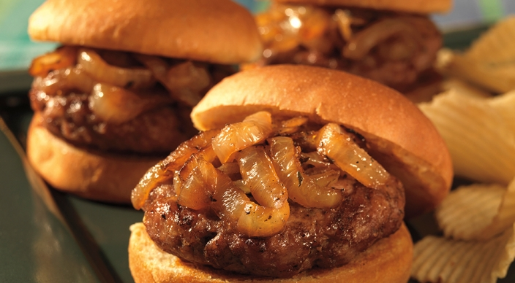
Pork Sliders

Relish
- 1 large yellow onion, cut into ¼-inch half-moons
- 1 tablespoon vegetable oil
- ½ teaspoon finely chopped fresh thyme leaves
- 3 tablespoons water
- 1 teaspoon red wine vinegar
- ½ teaspoon granulated sugar
- ⅛ teaspoon kosher salt
- ⅛ teaspoon freshly ground black pepper
Patties
- 1 pound lean ground pork
- 1 garlic clove, minced or pushed through a press
- 1 tablespoon soy sauce
- 1 teaspoon Chinese five spice
- ¼ teaspoon freshly ground black pepper
Also
- 12 slider buns, split
- 2 tablespoons unsalted butter, melted
Instructions
- Prepare the grill for direct cooking over medium heat (350° to 450°F) and preheat a grill-proof griddle for 10 minutes.
- In a small bowl mix the onion, oil, and thyme. Spread the onion mixture in a single layer on the griddle and cook over direct medium heat, with the lid closed, until browned and softened, about 15 minutes, turning occasionally. Add the remaining relish ingredients and continue cooking until the onion is fully softened and the liquid is absorbed, 2 to 4 minutes more. Remove from the griddle and set aside at room temperature until ready to serve. Keep the griddle on the cooking grates.
- In a medium bowl mix the patty ingredients, and then gently form into 12 patties of equal size, each about ½ inch thick. Lightly brush the cut side of the buns with butter.
- Brush the cooking grates clean. Grill the patties over direct medium heat, with the lid closed, until cooked to medium doneness (160°F), about 8 minutes, turning once. During the last minute of grilling time, toast the buns, cut side down, on the hot griddle. Place the patties on the buns and top with the sweet onion relish. Serve immediately.

