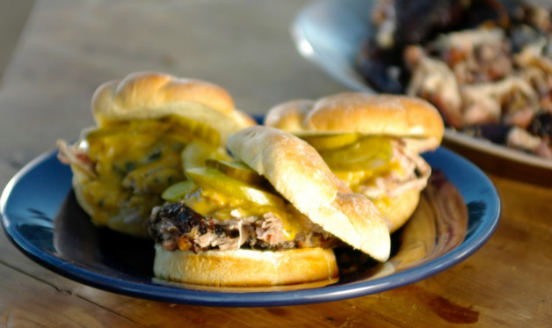
Pulled Pork Sandwiches

For the pork:
1 5-6 pound bone-in pork shoulder,
sometimes called Boston butt
3/4 cup of your favorite barbecue rub
1 bottle of beer

For the Mustard Barbecue Sauce:
1 cup Dijon-style mustard
1 cup brown sugar
1 cup distilled white vinegar
1 teaspoon liquid smoke
Sea salt and freshly ground black pepper

For the Mustard Slaw:
1 small head green cabbage (about 1 pound), cored, finely chopped or very thinly sliced
1 cup Mustard Barbecue Sauce from above

For serving:
12 sesame buns
1 stick salted butter, melted

Set up your grill for indirect grilling and preheat to 250 degrees.

Season the pork shoulder on all sides with the rub, massaging the spices into the meat. Place the spice rubbed pork shoulder fat side up in the center of the grate over the drip pan. Cover the grill and smoke-roast the pork 7 to 9 hours. The internal temperature, measured with an instant-read meat thermometer, should be 195 degrees. After the first hour, open a beer, cover the mouth of the bottle with your thumb, then shake it a little. Gradually slide your thumb back a little and direct the resulting stream of beer on the pork shoulder. This keeps it moist and gives it extra flavor.

Now make the sauce and slaw. For the sauce, combine the mustard, brown sugar, vinegar, and liquid smoke in a saucepan over medium-high heat and boil until thick, whisking to mix, 5 to 10 minutes. Let it cool to room temperature. Stir 1 cup of sauce into the chopped cabbage to make the mustard slaw. Reserve the remaining sauce for serving the pork.

Transfer the pork shoulder to a cutting board and let it rest for 20 minutes, loosely draped with a sheet of foil. (Do not bunch the foil around it or you’ll make the crust—also known as the bark—soggy.) Pull any skin off the pork shoulder and set it aside. Remove and discard the bone and any big lumps of fat. Chop the pork into small pieces with a cleaver. Place in a large bowl or roasting pan and stir in about 1 cup of Mustard Barbecue Sauce.

Meanwhile, rake the remaining charcoal in the grill into a mound. Brown and crisp any pork skin over the hot fire on both sides. Then chop it into small bits and mix them with the pork.

Brush the buns with melted butter. Arrange the buns on the grill grate directly over the coals and toast each until golden brown. Pile a generous mound of pork onto each bun. Top with mustard slaw. Serve any remaining slaw and/or sauce on the side.

