This needs to be started a day ahead for
the chorizo . . .
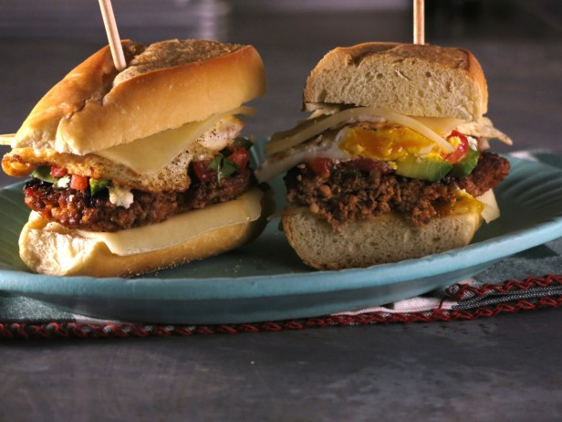
Pressed Egg Sandwiches

CHORIZO:
2 tablespoons canola oil
3 cloves garlic, finely chopped
1 shallot, finely diced
2 teaspoons dried Mexican oregano
1 teaspoon ground cumin
1 teaspoon smoked sweet Spanish paprika
1/4 teaspoon cayenne
1/4 cup cider vinegar
1 pound well-marbled ground pork shoulder
Kosher salt and freshly ground black pepper

SALSA:
3 plum tomatoes, seeded and finely diced
1/2 small jalapeño, seeded if desired, finely chopped
2 tablespoons finely chopped red onion
2 tablespoons finely chopped fresh cilantro
Kosher salt and freshly ground black pepper
2 tablespoons olive oil
Juice of 1 lime

SANDWICHES:
Canola oil, for cooking the patties
2 tablespoons unsalted butter, plus more melted for brushing
4 large eggs
Kosher salt and freshly ground black pepper

AND:
2 Cuban buns, each sliced open like a book
8 thin slices Monterey Jack cheese
1 ripe avocado, halved, pitted, peeled and thinly sliced
1/2 cup crumbled queso fresco

For the homemade chorizo: Heat the oil in a small skillet over medium heat. Add the garlic and shallot and cook for 1 minute. Add the oregano, cumin, paprika and cayenne and cook for 1 minute. Add a few tablespoons water and the vinegar and cook until thickened and fragrant, about 5 minutes. Remove from the heat, put in a blender and puree until almost smooth. Pour into a bowl and let cool to room temperature.

Add the ground pork to the spice mixture and gently mix to combine; season with salt and pepper. Cover and refrigerate for at least 2 hours and up to 24 hours to allow the flavors to meld.

For the salsa: Combine the tomatoes, jalapeño, onion and cilantro in a bowl. Toss with some salt and pepper. Add the olive oil and lime juice and toss again to combine. Let sit at room temperature to allow flavors to meld.

For the sandwiches: Form the pork mixture into 4 thin patties. Heat a few teaspoons of canola oil in a large cast-iron skillet over high heat until smoking. Add the sausage patties in batches of 2, if needed, and cook until golden brown and just cooked through, 3 to 4 minutes per side. Remove to a plate lined with paper towels and allow the excess fat to drain off.

Melt the butter in large nonstick pan over medium heat. Crack 4 eggs in and season the tops with salt and pepper. Cook until the whites are set and the yolks are slightly firm, about 2 minutes. Flip over and cook for 45 seconds longer.

While the eggs are cooking, open the buns on a flat surface. Put 2 slices of Jack cheese on each side of the open buns. Then, to the bottom halves of the buns, add 2 chorizo patties, some avocado slices, salsa, queso fresco and the 2 cooked eggs. Close the buns.

Press down on each sandwich. Brush the tops with the melted butter. Wipe out one of the pans. Add the sandwiches and weigh them down with foil-wrapped bricks, or put a piece of foil over the sandwiches and weight them down with another heavy skillet. Cook until the bottoms are toasted and the cheese melts, about 3 minutes.

