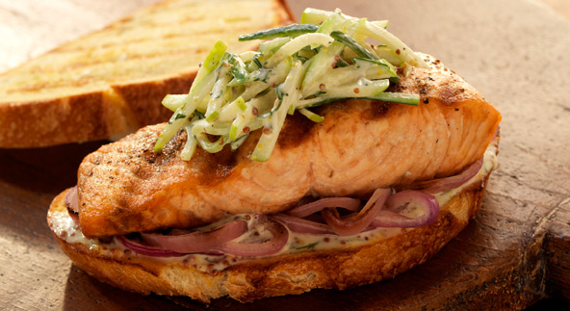
Salmon Club Sandwiches

Dressing
1/2 cup mayonnaise
1/4 cup roughly chopped fresh dill
5 tablespoons whole-grain Dijon mustard
1 tablespoon cider vinegar
1 tablespoon granulated sugar

Kosher salt
Freshly ground black pepper

1/2 English cucumber, about 6 ounces, unpeeled, cut into matchsticks or grated on the large holes of a box grater
1 Granny Smith apple, about 8 ounces, cored, unpeeled, and cut into matchsticks or grated on the large holes of a box grater

4 salmon fillets (with or without skin), each 6 to 8 ounces and about 1-1/4 inches thick, pin bones removed
4-1/2 tablespoons extra-virgin olive oil, divided
4 thin slices red onion
8 slices country-style bread

In a small bowl whisk the dressing ingredients. Season with salt and pepper. Set aside.

In a medium bowl combine the cucumber and apple. Add 1/4 cup plus 2 tablespoons of the slaw dressing and toss to coat. Season with a generous pinch of salt and more pepper, if desired. Cover and refrigerate while grilling the salmon. Chill the remaining dressing separately and reserve for spreading on the bread slices.

Prepare the grill for direct cooking over medium heat (350° to 450°F) on one side of the grill and direct cooking over high heat (450° to 550°F) on the other side.

Coat the salmon fillets with 1 tablespoon of the oil and season evenly with 3/4 teaspoon salt and 1/2 teaspoon pepper. Coat the onion slices with 1/2 tablespoon of the oil and lightly season with salt and pepper. Brush both sides of the bread slices with the remaining 3 tablespoons oil.

Brush the cooking grates clean. Grill the salmon over direct high heat, with the lid closed as much as possible, until you can lift the fillets off the cooking grates without sticking, 6 to 8 minutes. Turn the fillets over and continue cooking until just opaque in the center or to your desired doneness, 2 to 4 minutes for medium rare. At the same time, grill the onion slices over direct medium heat until tender and light grill marks appear, 5 to 6 minutes, turning once or twice. During the last 1 minute of grilling time, grill the bread slices over direct medium heat until lightly toasted and grill marks appear, turning once. Remove the salmon, onion, and bread from the grill.

If the salmon still has skin attached, remove it. Spread the reserved slaw dressing on one side of each bread slice, dividing it equally. Build the sandwiches with onion slices, a salmon fillet, and some of the slaw. Serve with the remaining slaw on the side.

