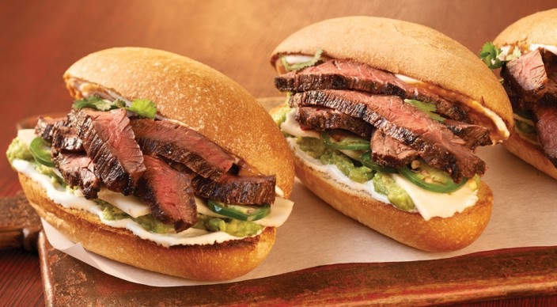
Carne Asada Tortas with Avocado

Rub
1/2 teaspoon kosher salt
1/4 teaspoon freshly ground black pepper
1/4 teaspoon garlic powder
And
1 pound skirt steak, about 1/2 inch thick, trimmed of excess surface fat, cut crosswise into 6-inch pieces
1–2 tablespoons olive oil
And
1/4 cup Mexican crema or sour cream
1/4 cup mayonnaise
1/2 cup canned refried beans
2 tablespoons store-bought tomato salsa
4 bolillos or torpedo sandwich rolls, split
1 large, ripe Hass avocado, mashed
2 ounces queso fresco, thinly sliced
1 jalapeño chile pepper, thinly sliced (optional)
1/2 cup loosely packed fresh cilantro leaves

Instructions

Prepare the grill for direct cooking over medium-high heat (450° to 500°F).

Combine the rub ingredients. Brush the skirt steak on both sides with the oil and season evenly with the rub.

Combine the Mexican crema with the mayonnaise.

Gently warm the refried beans in a microwave oven for 1 minute at 50 percent power. Stir in the salsa. Cover to keep warm.

Grill the steak over direct medium-high heat, with the lid closed, until cooked to your desired doneness, 4 to 6 minutes for medium rare, turning once. During the last 30 seconds to 1 minute of grilling time, toast the rolls, cut side down, over direct heat. Remove from the grill and let the steaks rest for 3 to 5 minutes.

Spread the rolls on both sides with the crema and mayonnaise mixture. Spread a layer of the beans and salsa mixture on one side of each roll and a layer of mashed avocado on the other side. Cut the steaks across the grain into thin slices, and then divide the steak, queso fresco, jalapeño (if using), and cilantro evenly among the rolls. Serve warm.

