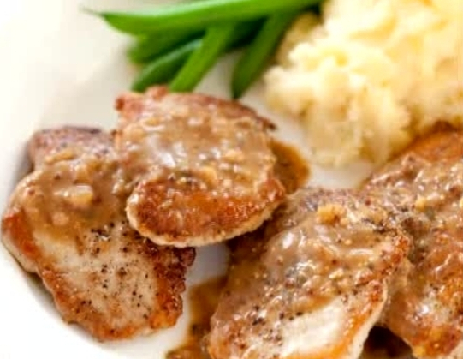
Pork w/ Mustard Cider Sauce

Why This Recipe Works
Instead of using supermarket pork cutlets for our sautéed pork cutlets recipe, we opted for boneless country-style spare ribs. We added sugar to our brine to help the pork cutlets retain moisture and encourage browning, then sautéed the pork cutlets in a combination of olive oil and butter, which promoted browning even further. For the pan sauce, we reduced a flour-thickened mixture of cider, stock, and seasonings and swirled in coarse mustard and butter for a rich, glossy sauce that perfectly coated our tender, browned sautéed pork cutlets.

Pork
2 tablespoons kosher salt, (or 1 tablespoon table salt)
1 ½ teaspoons sugar
1 ½ pounds boneless country-style pork spare ribs, trimmed of excess fat (see note)
ground black pepper
1 tablespoon olive oil
½ tablespoon unsalted butter, cut into 2 pieces

Mustard-Cider Sauce
1 tablespoon unsalted butter
1 small shallot, minced (about 2 tablespoons)
1 teaspoon unbleached all-purpose flour
1 teaspoon dry mustard
½ cup low-sodium beef or chicken broth
¼ cup apple cider
½ teaspoon minced fresh sage leaves
2 teaspoons whole-grain mustard
Table salt and ground black pepper

1. FOR THE PORK: Dissolve salt and sugar in 2 cups water in medium container or bowl. Set aside. Cut each rib lengthwise to create 2 or 3 cutlets about 3/8 inch wide. Place cutlets between 2 layers of plastic wrap and gently pound to ¼-inch thickness. Submerge cutlets in brine, cover with plastic wrap, and refrigerate 30 minutes.

2. FOR THE SAUCE: While pork brines, melt ½ tablespoon butter in small saucepan over medium heat; add shallot and cook, stirring frequently, until softened, about 1½ minutes. Add flour and dry mustard; cook, stirring constantly, 30 seconds. Slowly add broth, whisking constantly to avoid forming lumps. Add cider and sage and bring to boil. Reduce heat to low and simmer 5 minutes. Remove pan from heat, cover, and set aside. Adjust oven rack to middle position and heat oven to 200 degrees.

3. TO COOK PORK: Remove pork from brine, dry thoroughly with paper towels, and season with pepper. Heat oil in 12-inch skillet over medium-high heat until just beginning to smoke. Add 1 piece butter, allow to melt, and quickly add half of pork cutlets. Cook cutlets until browned, about 1 to 2 minutes. Using tongs, flip cutlets and continue to cook until browned on second side, 1 to 2 minutes longer. Transfer cutlets to large plate and transfer plate to warm oven. Repeat with remaining cutlets and remaining butter.

4. After second batch of cutlets is cooked, reduce skillet heat to medium, add reserved sauce, and bring to simmer. Cook, scraping pan bottom to loosen browned bits, until slightly thickened and reduced to about ½ cup, about 2 minutes. Stir in any accumulated pork juices; return to simmer and cook 30 seconds. Off heat, whisk in whole-grain mustard and remaining ½ tablespoon butter; season with salt and pepper to taste. Spoon sauce over pork and serve immediately.

