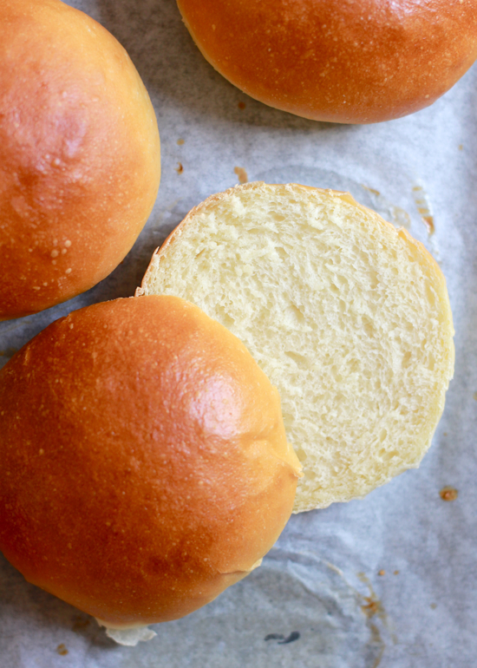
Light Brioche Hamburger Buns
8 ounces warm water
3 tablespoons warm milk
2 teaspoons active dry yeast
2 1/2 tablespoons sugar
2 large eggs
360 grams bread flour
40 grams all-purpose flour
1 1/2 teaspoons salt
2 1/2 tablespoons unsalted butter, softened.
Sesame seeds (optional)
Whisk together the warm water, milk, and sugar. Then, beat 1 egg.

In the bowl of a stand mixer, add the flours, salt, yeast, and butter. Using the paddle attachment, mix the ingredients until the butter is the size of crumbs.

Stir in milk/water mixture and beaten egg. Run the mixer on medium-low (I used #3 on my Kitchen Aid) until a dough forms, about 5-8 minutes. Scrape down the sides of the bowl if necessary, and shape the dough into a ball. Cover bowl with a damp kitchen towel and let the dough rise until it has doubled is size.

Line a baking sheet with parchment paper. Using a floured dough scraper (or chef’s knife), divide the dough into 8 equal pieces. If you have a scale, weigh each piece to guarantee that they’re all the same size.

To shape the dough into balls, gently flatten each piece like a pancake. Gather the ends and pinch the dough to seal in the center. Flip the dough over, cup the surface with your palm, and roll into a ball. Transfer to your baking sheet, placing them a few inches inches apart. Cover and rest for 1-2 hours, or until puffy and slightly risen.

To make the egg wash, beat the remaining egg with a splash of water. When the buns are finished with the 2nd rise, gently brush each one with egg wash. At this point, you could add sesame seeds to the top of your rolls if desired.

Preheat your oven to 400 F. and place a skillet or metal baking dish on the oven floor. Before the dough goes in, add about 1/2 cup of water to the pan to create steam. This will help keep the bread nice and moist. Bake for about 15-20 minutes or until golden brown. Transfer to a wire rack to cool completely.

