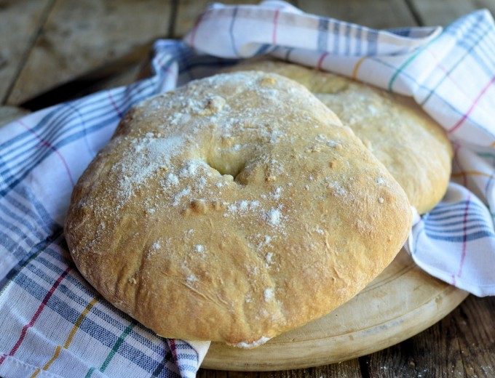
453g bread flour
145g milk – 105 degrees
110g water – 105 degrees
2 tsp yeast
1 tsp sugar
1 1/2 tsp Kosher salt
1 tbs vegetable oil

add sugar, yeast, oil
stir and let stand for 5 mins

whisk salt into flour

mix

knead for 10 mins

oil bowl … add dough ball … let stand covered 1hr, until doubled

coat two sheet pans with oil

knock down dough by kneading a few times

split dough … 370g each

make two dough balls

press out and then roll into an 8 inch disc

dust w/ flour

place on sheet tray and cover, do this twice … let rise, covered, for 30 mins

356 degrees oven … mark the top with a fork .. or poke hole in center

8 mins in oven … then rotate … 6 more mins in oven

make sure they are browned enough … add a few mins if necessary

place on wire rack to cool

