Chile Verde Pork Pozole

3 POUNDS BONELESS PORK BUTT, CUT INTO 2-INCH PIECES
1 HEAD OF GARLIC
1 MEDIUM WHITE ONION CHOPPED
6 POBLANO PEPPERS ROASTED AND PEELED
6 TOMATILLOS ROASTED
2 JALAPEÑO OR SERRANO PEPPERS ROASTED
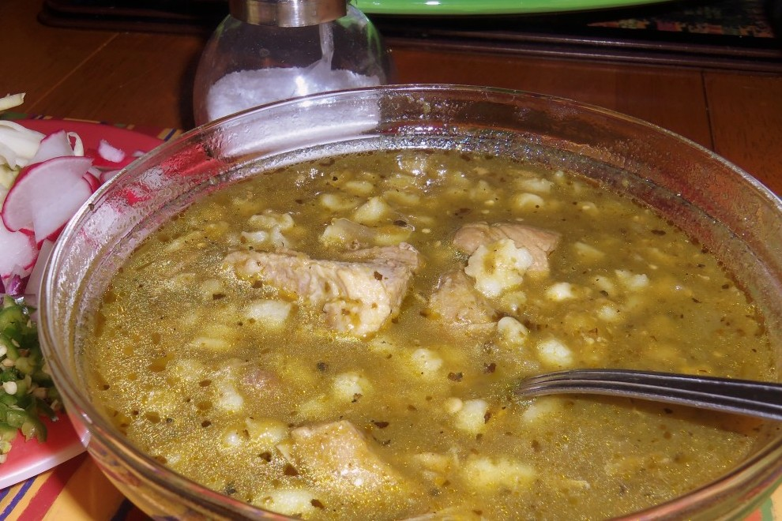
4 CUPS COOKED WHITE POZOLE-HOMINY
MEXICAN OREGANO
1 TABLESPOON WHOLE CUMIN SEEDS
TOASTED AND FRESHLY GROUND
(OR GROUND CUMIN)
SALT

For the Garnish
GREEN CABBAGE OR LETTUCE SHREDDED
RADISHES SLICED
SERRANO PEPPER MINCED
PEPITAS TOASTED
LEMON OR LIME WEDGES
RED ONION DICED
MEXICAN OREGANO

In a large pot, combine the pork, garlic, onion, salt (about 3 tablespoons) and enough water to cover, 8 to 10 cups. Bring to a boil, skimming the top, reduce heat and cook for a good 2½ to 3 hours.
When meat is tender, remove the garlic. I chose to leave the onions in, instead of straining them out.
Add 2 tablespoons of Mexican oregano, all of the hominy and the cumin, stir well to combine.
In the blender, combine the roasted poblano, jalapeño and tomatillos, 1 cup of water, blend until smooth.

Carefully add it to the pozole and stir well to combine. Once it comes to a boil, taste for salt, season as needed. You may want to add a little more water (about 1½ cups) to the pozole. Cook, partially covered for another hour or until pork is tender.

Serve with warm tortillas or tostadas. Garnish with your favorite toppings.

