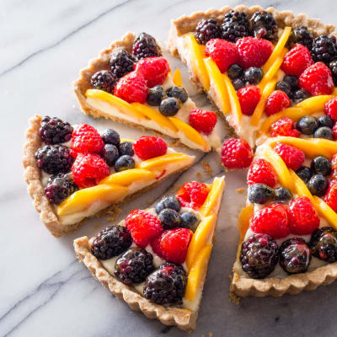
Fresh Fruit Tart / America’s Test Kitchen

By trading the traditional rolled pastry and pastry cream filling for easier, faster alternatives, we produced a fresh fruit tart that is as appealing to make as it is to eat. Stirring melted butter into the dry ingredients yielded a malleable dough that could be pressed into the pan; for extra flavor, we browned the butter first and added back the water that had cooked off so that there was enough moisture for the flour to form gluten (the protein network that would give the dough structure). A mix of mascarpone cheese, melted white baking chips, and lime juice and zest gave us a quick-to-make filling that was lush and creamy but also full-bodied and firm enough to slice cleanly. Arranging thin-sliced peaches in lines radiating from the center of the tart to its outer edge created cutting guides between which we artfully arranged a mix of berries. These guides ensured that we could slice the tart into neat portions without marring the arrangement of the fruit. A glaze of apricot preserves and lime juice brightened the fruit and gave the tart a polished, professional look.

Crust
1 1/3 cups (6 2/3 ounces) all-purpose flour
1/4 cup (1 3/4 ounces) sugar
1/8 teaspoon salt
10 tablespoons unsalted butter
2 tablespoons water

Tart
1/3 cup (2 ounces) white baking chips
1/4 cup heavy cream
1 teaspoon grated lime zest plus 7 teaspoons juice (2 limes)
Pinch salt
6 ounces (3/4 cup) mascarpone cheese, room temperature
2 ripe peaches, peeled
20 ounces (4 cups) raspberries, blackberries, and blueberries
1/3 cup apricot preserves

This recipe calls for extra berries to account for any bruising. Ripe, unpeeled nectarines can be substituted for the peaches, if desired. Use white baking chips here and not white chocolate bars, which contain cocoa butter and will result in a loose filling. Use a light hand when dabbing on the glaze; too much force will dislodge the fruit. If the glaze begins to solidify while dabbing, microwave it for 5 to 10 seconds.
1. FOR THE CRUST: Adjust oven rack to middle position and heat oven to 350 degrees. Whisk flour, sugar, and salt together in bowl. Melt butter in small saucepan over medium-high heat, swirling saucepan occasionally, until foaming subsides. Cook, stirring and scraping bottom of saucepan with heat proof spatula, until milk solids are dark golden brown and butter has nutty aroma, 1 to 3 minutes. Remove saucepan from heat and add water. When bubbling subsides, transfer butter to bowl with flour mixture and stir until well combined. Transfer dough to 9-inch tart pan with removable bottom and let dough rest until just warm, about 10 minutes.

2. Use your hands to evenly press and smooth dough over bottom and up side of pan (using two-thirds of dough for bottom crust and remaining third for side). Place pan on wire rack set in rimmed baking sheet and bake until crust is golden brown, 25 to 30 minutes, rotating pan halfway through baking. Let crust cool completely, about 1 hour. (Cooled crust can be wrapped loosely in plastic wrap and stored at room temperature for up to 24 hours.)

3. FOR THE TART: Microwave baking chips, cream, lime zest, and salt in medium bowl, stirring every 10 seconds, until baking chips are melted, 30 to 60 seconds. Whisk in one-third of mascarpone, then whisk in 6 teaspoons lime juice and remaining mascarpone until smooth. Transfer filling to tart shell and spread into even layer.

4. Place peach, stem side down, on cutting board. Placing knife just to side of pit, cut down to remove 1 side of peach. Turn peach 180 degrees and cut off opposite side. Cut off remaining 2 sides. Place pieces cut side down and slice 1/4 inch thick. Repeat with second peach. Select best 24 slices.

5. Evenly space 8 berries around outer edge of tart. Using berries as guide, arrange 8 sets of 3 peach slices in filling, slightly overlapping slices with rounded sides up, starting at center and ending on right side of each berry. Arrange remaining berries in attractive pattern between peach slices, covering as much of filling as possible and keeping fruit in even layer.

6. Microwave preserves and remaining 1 teaspoon lime juice in small bowl until fluid, 20 to 30 seconds. Strain mixture through fine-mesh strainer. Using pastry brush, gently dab mixture over fruit, avoiding crust. Refrigerate tart for 30 minutes.

7. Remove outer metal ring of tart pan. Slide thin metal spatula between tart and pan bottom to loosen tart, then carefully slide tart onto serving platter. Let tart sit at room temperature for 15 minutes. Using peaches as guide, cut tart into wedges and serve. (Tart can be refrigerated for up to 24 hours. If refrigerated for more than 1 hour, let tart sit at room temperature for 1 hour before serving.)

