Chipotle Skirt Steak Fajitas with Avocado Cream

Marinade
3 tablespoons minced canned chipotle chile peppers in adobo sauce
2 tablespoons extra-virgin olive oil
2 tablespoons fresh lime juice
2 tablespoons packed light brown sugar
3 garlic cloves, minced
1 teaspoon kosher salt
1 teaspoon ground cumin

1½ pounds skirt steak, ½ to ¾ inch thick, trimmed
of excess surface fat, cut crosswise into 4- to 5-inch pieces

Cream
1 large, ripe Hass avocado
⅓ cup sour cream
1 tablespoon fresh lime juice
½ teaspoon kosher salt
½ teaspoon hot pepper sauce

Also
8–10 flour or corn tortillas (6 to 8 inches)
⅔ cup chopped red onion
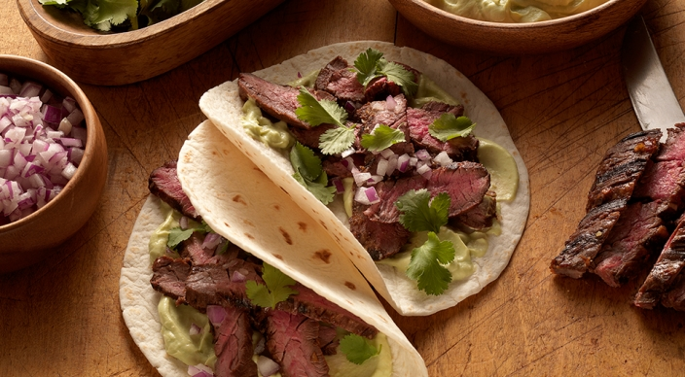
Fresh cilantro leaves

In a small bowl whisk the marinade ingredients. Place the steak pieces in a large resealable plastic bag and pour in the marinade. Press the air out of the bag and seal tightly. Turn the bag to distribute the marinade, place in a bowl, and refrigerate for 2 to 8 hours. Allow the steaks to stand at room temperature for 15 to 30 minutes before grilling.

Prepare the grill for direct cooking over high heat (450° to 550°F).

In a food processor combine the cream ingredients and process until smooth. Transfer to a bowl and cover with plastic wrap until ready to use.

Remove the steaks from the bag and discard the marinade. Brush the cooking grates clean. Grill the steaks over direct high heat, with the lid closed, until cooked to your desired doneness, 4 to 6 minutes for medium rare, turning once or twice. Remove from the grill and let rest for 3 to 5 minutes. Cut the steaks across the grain into thin slices.

Spread half of each tortilla with avocado cream and top with steak slices, onion, and cilantro. Serve immediately.

