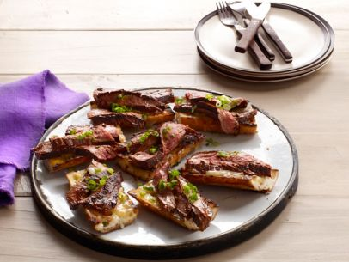
Flank Steak With Balsamic Barbecue Sauce

For the sauce and steak:
1 1/2 cups balsamic vinegar
2 tablespoons canola oil
1 small onion, coarsely chopped
1 large clove garlic, coarsely chopped
1/2 cup ketchup
1 tablespoon ancho chile powder
1 1/2 teaspoons paprika
2 teaspoons dijon mustard
1 1/2 teaspoons red wine vinegar
1 1/2 teaspoons Worcestershire sauce
1 small chipotle chile in adobo sauce, chopped
1 1/2 teaspoons packed dark brown sugar
2 teaspoons honey
2 teaspoons molasses

Kosher salt and freshly ground pepper
2 pounds flank steak

For the cheesy bread:
1 French baguette, halved lengthwise and cut into 4-inch pieces
Extra-virgin olive oil
Kosher salt and freshly ground pepper
1 cup grated monterey jack cheese
Sliced scallions, for serving

Make the sauce: Bring the balsamic vinegar to a simmer in a small saucepan over medium heat and cook until reduced by about half, 15 to 20 minutes. Set aside. Heat 1 tablespoon canola oil over medium-high heat in a heavy- bottomed medium saucepan. Add the onion and cook until soft, 3 to 4 minutes. Add the garlic and cook 1 minute. Add the ketchup and 3 tablespoons water and bring to a boil. Reduce the heat to a simmer and cook 5 minutes. Add the reduced balsamic vinegar, the chile powder, paprika, mustard, red wine vinegar, Worcestershire sauce, chipotle chile, brown sugar, honey and molasses. Simmer until thickened, stirring occasionally, 10
minutes. Puree with an immersion blender or transfer to a blender and puree until smooth. Season with salt and pepper. Pour the sauce into a bowl and let cool to room temperature. (The sauce will keep for 1 week refrigerated in a sealed container. If it gets too thick, stir in 1 to 2 tablespoons water.)

Prepare the steak: Let the steak sit 30 minutes at room temperature before grilling. Meanwhile, preheat a grill to high. Brush the steak with the remaining 1 tablespoon canola oil and season liberally with salt and pepper. Grill over direct heat until browned on one side, about 3 minutes, then turn over and grill until the other side is browned, about 3 more minutes. Move to a cooler part of the grill, away from direct heat. Baste with the sauce and continue grilling, turning several more times, until medium rare, about 5 more minutes. Transfer to a cutting board and loosely tent with foil. Let rest 10 minutes.

Meanwhile, make the cheesy bread: Brush the cut side of each piece of bread with olive oil and season with salt and pepper. Grill on both sides. Remove from the grill and top each piece with a mound of grated monterey jack cheese. Put the bread on a piece of aluminum foil and return to the grill to melt the cheese. Transfer to a serving platter.

Thinly slice the steak against the grain. Arrange the steak slices on the bread and garnish with sliced scallions.

