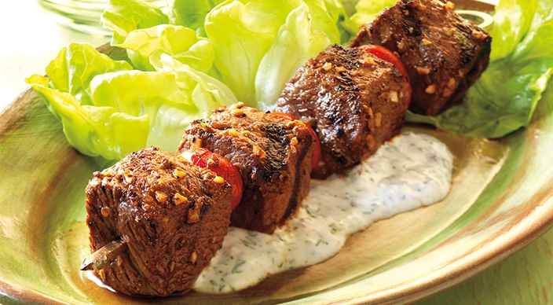
Beef and Tomato Kebabs

Marinade
- 2 tablespoons fresh lemon juice
- 2 tablespoons extra-virgin olive oil
- 1 tablespoon minced garlic
- 2 teaspoons kosher salt
- 1 teaspoon ground cumin
- 1 teaspoon smoked paprika
- ½ teaspoon freshly ground black pepper
- ½ teaspoon ground coriander
- ½ teaspoon fennel seed, crushed

2 pounds top sirloin, about 1¼ inches thick, trimmed of excess fat, cut into 1¼-inch cubes
1 pint grape tomatoes (about 20 tomatoes)

Dressing
- ⅔ cup plain yogurt or sour cream
- 3 tablespoons buttermilk
- 2 tablespoons minced red onion
- 2 tablespoons finely chopped fresh dill
- 1 tablespoon extra-virgin olive oil
- 1 tablespoon fresh lemon juice
- 1 small clove garlic, minced or pushed through a press

1 head butter lettuce, leaves separated

Instructions
- In a large bowl combine the marinade ingredients. Place the meat cubes in the bowl and turn in the marinade to coat evenly. Allow to stand at room temperature for 30 minutes, or cover and refrigerate for up to 4 hours.

- Prepare the grill for direct cooking over high heat (450° to 550°F).

- Thread the meat onto skewers, alternating with the tomatoes.

- In a bowl whisk the dressing ingredients.

- Brush the cooking grates clean. Grill the kabobs over direct high heat, with the lid closed, until the meat is cooked to your desired doneness, 6 to 8 minutes for medium rare, turning occasionally. Spread the lettuce leaves on a platter, top with the kabobs, and serve with the dressing.

