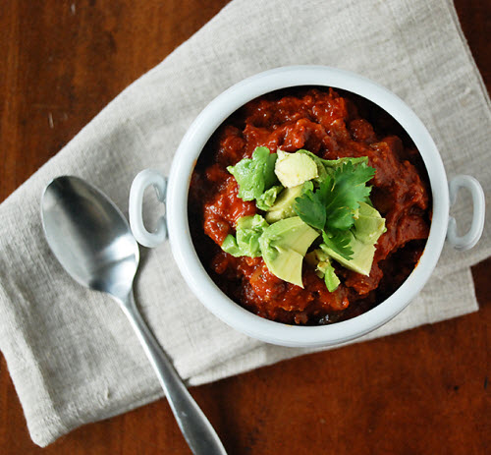
Paleo Bison Chili

1 chipotle pepper in adobo sauce, minced
1 1/2 teaspoons coconut oil
1 cup chopped yellow onion
1 cup chopped green bell pepper
1 cup chopped red bell pepper
4 garlic cloves, minced
1 pound ground bison
1/2 pound spicy ground pork sausage
1 tablespoon chili powder
1 tablespoon ground cumin
1 teaspoon dried oregano
1 teaspoon unsweetened cocoa powder
1 teaspoon Worcestershire sauce
1 (28 ounce) can crushed tomatoes
1 1/2 teaspoons kosher salt
1/2 teaspoon ground black pepper

Directions
1. Melt coconut oil in a large pot over medium heat. Cook and stir onion, green bell pepper, and red bell pepper until tender, 5 to 10 minutes. Stir garlic and minced chipotle into onion mixture and cook until fragrant, about 1 minute.
2. Stir bison and sausage into onion mixture. Cook and stir until meat is browned and crumbly, 10 to 12 minutes.
3. Stir chili powder, cumin, oregano, cocoa powder, and Worcestershire sauce into the bison mixture; add crushed tomatoes, salt, and pepper and stir. Bring to a boil, reduce heat to low, and simmer until flavors are blended, 10 minutes.

