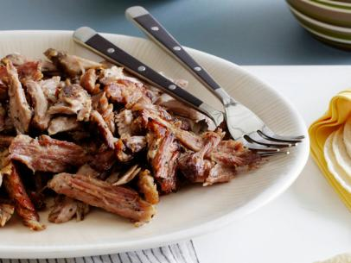
Carnitas

Ingredients
2 pounds boneless pork shoulder (or 2 1/2 pounds bone-in)
Salt and freshly ground black pepper
2 teaspoons dried oregano
1 teaspoon ground cumin
1 tablespoon olive oil
1 onion, coarsely chopped
4 cloves garlic, minced
1 jalapeno, seeded and ribs removed, chopped
1 orange, cut in half
3 tablespoons vegetable oil
Directions
Rinse and dry the pork shoulder. Salt and pepper liberally. Mix the oregano and the cumin with olive oil and rub all over pork. Place the pork in a slow cooker and top with the onion, garlic, and jalapeno. Squeeze over the juice of the orange and add the two halves. Cover and cook on low for 8 to 10 hours or on high 4 hours.
Once the meat is tender, remove from slow cooker and let cool slightly before pulling apart with a fork. In a large saute pan, heat the vegetable oil over high heat. Press the carnitas into the oil and fry until crusty on one side. Serve.

