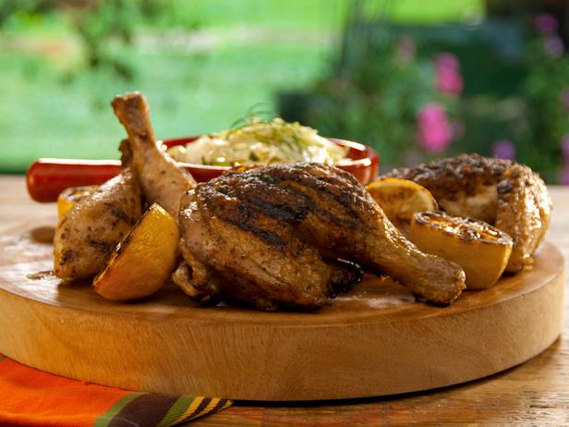
Brined Butterflied Chicken Alla Diavola

Brine:
1 cup kosher salt
1 teaspoon whole black peppercorns
1 head garlic, halved lengthwise
4 whole chiles de arbol, crushed
4 cups ice cubes
One 3-pound whole chicken, butterflied

Chile Oil:
1 cup extra-virgin olive oil
8 whole black peppercorns
6 dried chiles de arbol, lightly toasted and crushed
6 cloves garlic, chopped
1 teaspoon fresh oregano leaves
1 teaspoon kosher salt

Garnish:
3 lemons, halved and grilled
Parsley leaves

For the brine: Bring 4 cups water, the salt, peppercorns, garlic and chiles to a boil. Stir until the salt is dissolved. Remove the brine from the heat and cool slightly. Stir in the ice cubes. The brine should be cold when you add the chicken. Add the chicken, cover and refrigerate for at least 1 hour and up to 4 hours.

Remove the chicken from the brine, rinse well with cold water and pat dry. Place the chicken skin-side up on a baking rack set over a baking sheet. Refrigerate the chicken for at least 1 hour and up to 4 hours. This will allow the chicken skin to dry out and produce a crisper crust on the grill.

Meanwhile, for the chile oil: Combine the oil, peppercorns, chiles, garlic, oregano and salt in a small saucepan over low heat and simmer. Remove the saucepan from the heat and keep at room temperature for at least 30 minutes and up to 4 hours. Transfer the oil to a blender and blend until smooth. Drain the oil into a bowl.

Heat the grill for direct medium heat and indirect grilling. If using charcoal, make sure the bottom vents and top vents of the grill are open.

Remove the chicken from the refrigerator 30 minutes before grilling. Brush the chicken with 3 tablespoons of the chile oil and sprinkle with salt and pepper. Place the chicken skin-side down over the coals, on direct heat. Grill the chicken until the skin is golden brown and crispy, about 10 minutes. Flip the chicken and move it over the indirect heat. Cover the grill and cook the chicken until a meat thermometer inserted into the thickest part of the thigh registers 160 degrees F, about 30 minutes. Add coals as necessary to maintain the grill temperature at about 400 degrees F.

Transfer the chicken to a cutting board; wait 10 minutes before carving. Carve the chicken and drizzle with the remaining chile oil. Garnish the chicken with grilled lemon halves and parsley leaves. Serve with the lemony fennel slaw on the side.

