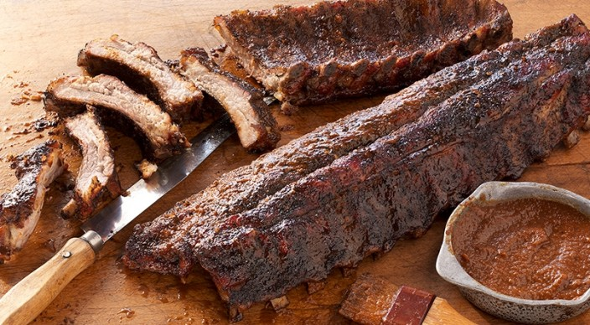
Rub
2 tablespoons ground coffee
1 tablespoon packed dark brown sugar
1 tablespoon smoked paprika
1 tablespoon kosher salt
2 teaspoons coarsely ground black pepper
1/2 teaspoon garlic powder

2 meaty racks baby back ribs, each
2 to 2 1/2 pounds

Sauce
2 tablespoons unsalted butter
1 1/2 cups minced yellow onion
3/4 cup strong brewed coffee
1/2 cup ketchup
2 tablespoons packed dark brown sugar
2 tablespoons cider vinegar
2 tablespoons molasses
1 tablespoon Worcestershire sauce
1 teaspoon smoked paprika
1 teaspoon mustard powder

Combine the rub ingredients. Using a dull knife, slide the tip under the membrane covering the back of each rack of ribs. Lift and loosen the membrane until you can pry it up, then grab a corner of it with a paper towel and pull it off. Season the racks evenly all over with the rub and allow them to stand at room temperature for 45 minutes before grilling.

Prepare the grill for indirect cooking over low heat (250° to 350°F).

Meanwhile, make the sauce. In a saucepan over medium-high heat, melt the butter. Add the onion and cook until softened and beginning to brown, 7 to 8 minutes, stirring occasionally. Stir in the remaining sauce ingredients and bring to a boil. Reduce the heat to medium-low and simmer, uncovered, until slightly thickened and reduced to 1 1/2 cups, 16 to 18 minutes. Remove from the heat. If you prefer a smooth sauce, use an immersion blender or regular blender to puree the sauce.

Place the racks standing upright in a rib rack, both facing the same direction. Place the rib rack over indirect low heat, as far from the heat as possible, close the lid, and cook for 2 1/2 hours. After the first hour, baste the racks with water, particularly any areas that are looking a little dry. Continue to baste with water every 30 minutes or so. After 3 hours, check to see if one or both racks are ready to come off the grill. They are done when the meat has shrunk back from the ends of most of the bones by ¼ inch or more. Lift a rack by picking up one end with tongs. It should bend in the middle and the meat should tear easily. If the meat does not tear easily, return the racks to the rib rack on the grill, close the lid, and continue cooking for about 30 minutes more.

Remove the racks from the grill and lightly brush them on both sides with some of the sauce. Wrap each rack individually in heavy-duty aluminum foil. Return the racks to the grill and cook over indirect low heat, with the lid closed, until very tender, 30 to 45 minutes more. Remove from the grill and cut the racks between the bones into individual ribs. Serve warm with the remaining sauce.

