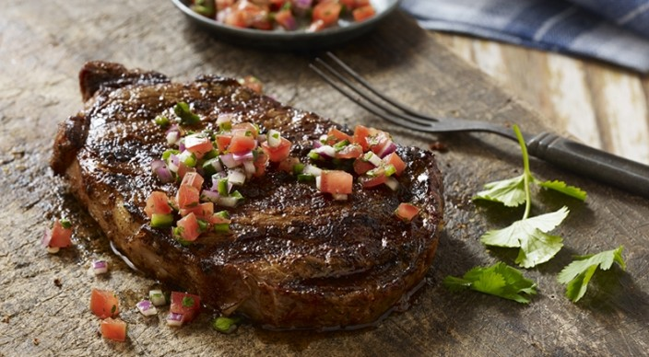
Cowboy Steaks

Paste
1 tablespoon extra-virgin olive oil
2 teaspoons ancho chile powder
2 teaspoons kosher salt
1 teaspoon paprika
2 garlic cloves, minced or pushed through a press
1/2 teaspoon freshly ground black pepper

And
4 boneless rib eye steaks, each about 12 ounces and 1 inch thick, trimmed of excess fat

Salsa
2 medium, ripe tomatoes, seeded and finely chopped
1/2 cup finely chopped red onion
1 small poblano chile pepper, stemmed, seeded, and finely chopped
1 small jalapeño chile pepper, stemmed, seeded, and finely chopped
1/4 cup finely chopped fresh cilantro leaves
2 tablespoons fresh lime juice
3/4 teaspoon teaspoon kosher salt
1/2 teaspoon freshly ground black pepper
1/2 teaspoon ground cumin
1 garlic clove, minced or pushed through a press

Mix the paste ingredients. Spread the paste on both sides of the steaks. Allow the steaks to stand at room temperature for 15 to 20 minutes before grilling.
Meanwhile, combine the salsa ingredients. Set aside until ready to serve.
Prepare the grill for direct cooking over high heat (450° to 550°F).
Grill the steaks over direct high heat, with the lid closed, until cooked to your desired doneness, 6 to 8 minutes for medium rare, turning once. Remove from the grill and let rest for 3 to 5 minutes. Serve warm with the salsa.

