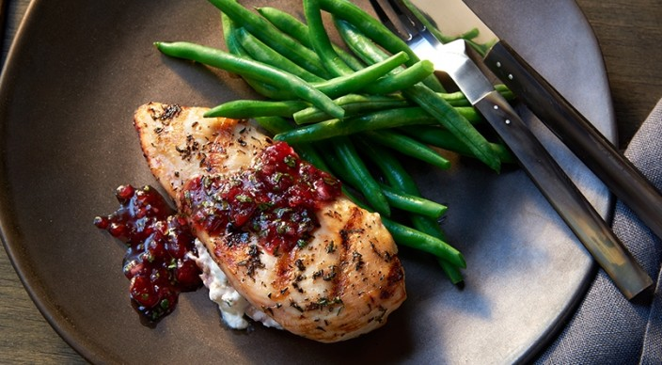
Goat Cheese-Stuffed Chicken Breasts
Salsa
1 can (14 ounces) whole cranberry sauce
⅓ cup finely chopped fresh cilantro leaves
¼ cup minced red onion
1½ teaspoons freshly grated orange zest
1 teaspoon balsamic vinegar

And
Kosher salt
¼ cup crumbled goat cheese
4 boneless chicken breast halves (with or without skin), each about 6 ounces
Freshly ground black pepper
2 tablespoons extra-virgin olive oil
2 teaspoons finely chopped fresh thyme leaves

Instructions

Combine the salsa ingredients, including ½ teaspoon of the salt, and mix well. Reserve ¼ cup of the salsa to use as a stuffing for the chicken breasts. (The salsa is best if made a few hours before serving. Keep it covered and refrigerated.)

Prepare the grill for direct cooking over medium heat (350° to 450°F).

Place the chicken on a work surface, skin (or smooth) side down, and then cut a large pocket in the thickest part of each breast. Push about 1 tablespoon of the cheese inside the pocket, and then spread about 1 tablespoon of the reserved cranberry mixture on top of the cheese. Press the pocket closed. Brush both sides of the chicken with oil and season evenly with the remaining ½ teaspoon salt, the pepper, and thyme.

Grill the chicken, skin (or smooth) side down first, over direct medium heat, with the lid closed, until the meat is firm to the touch and opaque all the way to the center, 8 to 12 minutes, carefully turning once. Remove from the grill and let rest for 3 to 5 minutes. Serve warm with the remaining cranberry salsa.

