Garlic-Lime Grilled Pork Tenderloin Steaks
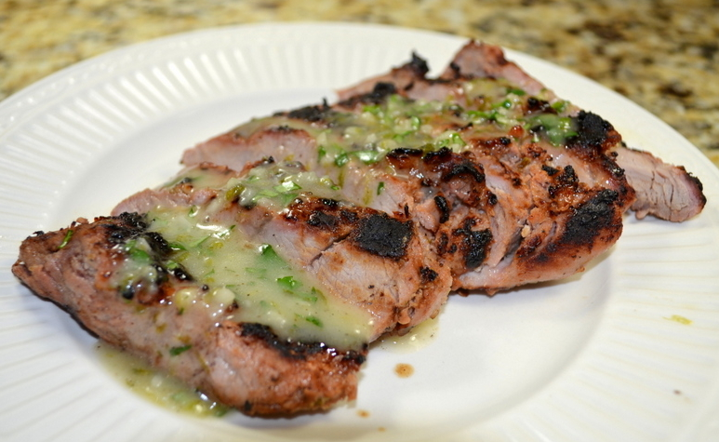
2 (1-pound) pork tenderloins, trimmed
2 limes; zested and squeezed
4 garlic cloves, minced
4 teaspoons honey
2 teaspoons fish sauce
3/4 teaspoon salt
1/2 teaspoon pepper
1/2 cup vegetable oil
4 teaspoons mayonnaise
1 tablespoon chopped fresh cilantro
Flake sea salt (or Kosher Salt)
Trim tenderloins and remove silver-skin. Use sharp knife to cut both tenderloins in half crosswise which will create 4 individual, half-length steaks. Use a meat pounder to flatten each half to 3/4″ thickness. Cut 1/8”-deep slits spaced 1/2″ apart in crosshatch pattern on both sides of all the steaks.
In a large bowl, whisk together lime zest and juice from 2 limes (1 tablespoon grated lime zest plus 1/4 cup juice), 4 garlic cloves garlic, 4 teaspoons honey, 2 teaspoons fish sauce, 3/4 teaspoon salt, 1/2 teaspoon pepper together. While whisking, slowly drizzle 1/2 cup vegetable oil into lime mixture until it slightly thickens and becomes smooth.
Measure out 1/2 cup lime mixture into small, microwavable bowl, and whisk in 4 teaspoons mayonnaise; set aside sauce.
Add steaks to the large bowl with remaining marinade and toss thoroughly to coat. Empty steaks and marinade into large, gallon-sized zip-lock bag. Press out as much air as possible, then seal the bag. Let steaks stand at room temperature for 45 minutes.
Remove steaks from bag, but do NOT pat dry. Cook, uncovered, over hot-side of grill for 3 to 4 minutes until well-browned. Flip and continue cooking the second side for another 3 to 4 minutes until well-browned. Move steaks to the cooler side of the grill, arranging so that the wider end of each steak is facing hotter part of grill. Cover grill and cook for 3 to 8 minutes longer (remove steaks when their internal temperature reaches 140 degrees).
Allow steaks to rest on a carving board for 5 minutes.
Meanwhile microwave sauce for 15 to 30 seconds until warm. Stir in chopped cilantro.
Slice steaks against grain into 1/2″ thick slices. Drizzle with the sauce and sprinkle with sea salt.

