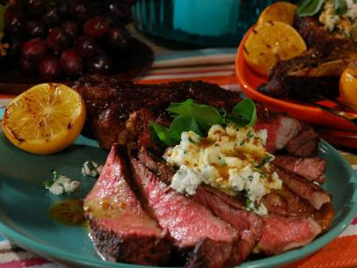
Goat Cheese Ribeye Steak

4 (1 1/2-inch thick) bone-in rib eye steaks, excess fat trimmed
1/2 cup clover honey
2 tablespoons Dijon mustard
2 tablespoons whole grain mustard
2 Meyer lemons, juiced
1 (11-ounce) log soft goat cheese, slightly softened
1/4 cup (total) finely chopped fresh thyme, parsley, chervil
2 tablespoons California olive oil
Salt and freshly ground black pepper
Canola oil
1 bunch watercress (or equivalent amount of Arugula)
2 Meyer lemons, halved and lightly grilled
Remove the steaks from the refrigerator 30 minutes before cooking and let sit at room temperature.
Preheat the grill for high direct and indirect heat.
Whisk together the honey, Dijon mustard, whole grain mustard and lemon juice in a small bowl and let sit at room temperature for at least 30 minutes to allow the flavors to meld.
Mix together the cheese, herbs and olive oil in a bowl until combined and season with salt and pepper. Refrigerate until ready to use.
Brush the steaks with canola oil and sprinkle liberally with salt and pepper. Grill over direct heat until slightly charred, about 5 minutes. Flip the steaks and move it away from the coals, close the cover and grill until an instant-read thermometer inserted into the center registers 135 degrees F, about 10 minutes. Remove from the grill to a cutting board.
Top the steaks with the goat cheese and drizzle with the vinaigrette. Scatter the watercress (or Arugula) over the tops, and then finish with a good drizzle of olive oil. Garnish the platter with the grilled lemon halves.

