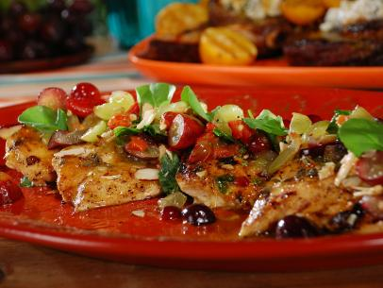
Grape Chicken Salad

Vinaigrette:
1/4 cup chardonnay vinegar
1 tablespoon Dijon mustard
1 tablespoon whole grain mustard
Salt and freshly ground black pepper
1/3 cup extra-virgin olive oil, plus more if needed
Grape Salad:
3 Fresno chiles
Canola oil
Salt and freshly ground black pepper
2 cups green seedless grapes, roughly chopped
2 cups red seedless grapes, roughly chopped
2 to 3 tablespoons chardonnay vinegar
2 to 3 tablespoons extra-virgin olive oil
Chicken:
3/4 cup apricot jam
3 tablespoons chardonnay vinegar
4 (6-ounce) boneless, skinless chicken breasts, pounded thin
Canola oil
Salt and freshly ground black pepper
1/4 cup roughly chopped fresh thyme
1 bunch watercress, for serving
For the vinaigrette: Whisk the vinegar, the mustards and salt and pepper, to taste, in a bowl. Slowly whisk in the olive oil until emulsified. Taste; whisk in a few more tablespoons olive oil, if desired.
For the grape salad: Prepare the grill for direct grilling. Brush the chiles with oil and season with salt and pepper. Grill until charred on all sides. Remove to a bowl, cover and let steam for 15 minutes. Remove the skins and coarsely chop. Transfer to a bowl and add the grapes, chardonnay vinegar and olive oil. Season with salt and pepper.
For the chicken: Whisk together the apricot jam and vinegar. Season with salt and 1/4 teaspoon black pepper.
Brush the chicken on both sides with oil and sprinkle with salt and pepper. Grill until the first side is golden brown, about 2 1/2 minutes. Turn, brush with the glaze and sprinkle on the thyme. Cook until just cooked through, another 2 to 3 minutes. Remove to a serving platter.
To serve, top with the grape salad and watercress. Drizzle with the vinaigrette.

