Flank Steak Pinwheels
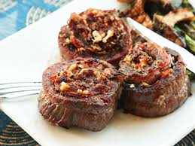
Ingredients

1 large flank steak, butterflied along the grain
Salt and freshly ground black pepper
6 ounces Asiago, shredded
8 ounces curly loose spinach leaves, washed, patted dry, stems removed
6 ounces Gorgonzola, crumbled
4 scallions, left whole
8 to 10 wooden skewers, soaked in water

Preheat grill or grill pan to high.

To butterfly the flank steak, start with the meat grain running up and down in front of you. With your knife, begin cutting the meat in half. Essentially, you want a thinner, larger flank steak. Continue cutting the flank steak in half until you reach about 1 inch from completely cutting through. Lay the cut flank steak open and even out the middle so there is not a thicker piece in the
center. Or just ask the butcher!

Spread the flank steak out so that the grain is running left to right. Beginlayering the flank steak with salt and pepper, the Asiago, then the spinach, the Gorgonzola and scallions. Begin rolling the flank steak tightly and away from you. Evenly insert the skewers 1 to 2 inches along the seam of the
pinwheel to hold it together on the grill. Cut in between each skewer but not against the skewer; you want the same amount of meat on either side of each skewer. Grill the pinwheels on each side for about 3 to 4 minutes or until your desired doneness.

