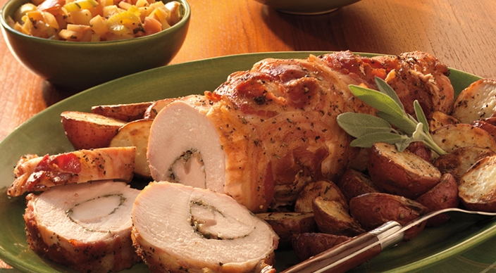
Pancetta-wrapped Turkey Breast

1 boneless turkey breast half (with skin),
about 3 pounds, butterflied
1 tablespoon plus 2 teaspoons finely
chopped fresh rosemary leaves, divided
1 tablespoon finely chopped fresh sage leaves
2 teaspoons finely grated lemon zest
2 large garlic cloves, minced or
pushed through a press
Kosher salt
Freshly ground black pepper
4 ounces pancetta, thinly sliced
1 tablespoon unsalted butter, melted

Relish
Vegetable oil
1 tablespoon finely chopped fresh sage leaves
½ large yellow onion, cut into ½-inch dice (about 1 cup)
2 sweet-tart apples, such as Pink Lady or Jazz,
each about 8 ounces, unpeeled, cored, and
cut into ½-inch dice (about 3 generous cups)
2 ribs celery, finely sliced (about 1 cup)
½ cup water
3 tablespoons fresh lemon juice
2 tablespoons honey
1 teaspoon cider vinegar

2 pounds new red potatoes, about 1½ inches in diameter, each cut in half

Instructions

Place the butterflied turkey breast, skin side down, between two large sheets of plastic wrap, and pound to an even ½-inch thickness (the size of the turkey breast will be approximately 12 by 11 inches).

In a small bowl combine 1 tablespoon of the rosemary, the sage, lemon zest, garlic, ½ teaspoon salt, and ¼ teaspoon pepper. Sprinkle the mixture evenly over the turkey breast, and then roll up the turkey breast lengthwise to create a cylinder. Cover with the pancetta slices, overlapping them slightly, and then tie the cylinder with butcher’s twine at 2-inch intervals to secure the pancetta and maintain its shape. Brush the outside all over with the melted butter. Season evenly with 1 teaspoon of the rosemary, ¾ teaspoon salt, and ½ teaspoon pepper.

Before you light the grill, place a large disposable foil pan underneath the cooking grate to catch the pancetta drippings. Prepare the grill for direct and indirect cooking over medium heat (350° to 450°F).

Pancetta-wrapped Turkey Breast (pg 2)

Brush the cooking grates clean. Center the turkey over the foil pan and grill over indirect medium heat, with the lid closed, until an instant-read thermometer inserted into the thickest part of the breast registers 160° to 165°F, about 1 hour 20 minutes, turning two or three times. Meanwhile, make the apple relish.

In a medium skillet over medium heat, warm 1 tablespoon oil. Add the sage and swirl to release its fragrance, 20 to 30 seconds. Add the onion and cook until tender, about 5 minutes, stirring frequently. Add the apples and celery and cook for 2 minutes more, stirring occasionally. Add the water, lemon juice, honey, vinegar, ¼ teaspoon salt, and ⅛ teaspoon pepper. Bring to a simmer, cover, and cook until the apples are no longer crunchy but are still slightly firm to bite, about 3 minutes. Remove from the heat and cool to room temperature.

After the turkey has cooked for about 40 minutes, place a perforated grill pan on the cooking grates over direct medium heat and preheat for 10 minutes. Put the potatoes in a medium bowl and toss with 2 teaspoons oil, the remaining 1 teaspoon rosemary, 1 teaspoon salt, and ½ teaspoon pepper. Spread the potatoes in a single layer on the grill pan and grill over direct medium heat until browned in spots and tender, 20 to 25 minutes, turning occasionally.

Transfer the turkey to a cutting board and let rest for 10 minutes. Remove the twine and cut the turkey crosswise into ½-inch slices. Serve warm with the potatoes and the relish.

