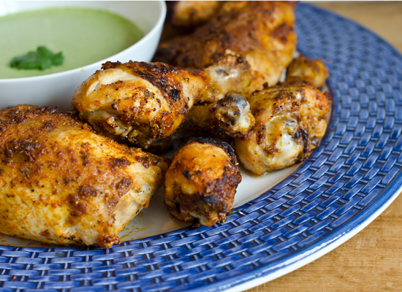
Peruvian Roast Chicken

For the Chicken:
3 tablespoons extra virgin olive oil
1/4 cup lime juice, from 2 limes
4 large garlic cloves, roughly chopped
1 tablespoon kosher salt
2 teaspoons paprika
1 teaspoon black pepper
1 tablespoon cumin
1 teaspoon dried oregano
2 teaspoons sugar
4 pound whole chicken

For the Aji Verde:
3 jalapeño chili peppers, seeded if desired, and roughly chopped
1 cup fresh cilantro leaves
2 cloves garlic, roughly chopped
1/2 cup mayonnaise
1/4 cup sour cream
1 tablespoon fresh lime juice, from one lime
1/2 teaspoon salt
1/8 teaspoon freshly ground black pepper
2 tablespoons extra virgin olive oil

For the Chicken:
Combine all of the ingredients except the chicken in a blender or mini food processor, and blend until smooth. Remove the giblets from the inside of the chicken and pat the outside of the chicken dry with paper towels; place in a bowl, breast side up with the legs facing you. Using the handle of a wooden spoon or your fingers, loosen the skin from the flesh over the breasts and legs, being careful not to tear the skin or push all the way through (you want the marinade to stay inside the bird). Spoon about 2/3 of the marinade evenly underneath the skin, and spread the remaining 1/3 evenly over the skin. Marinate the chicken in the refrigerator for at least 6 hours or overnight.

Adjust the oven rack to the lower-middle position, and preheat the oven to 425 degrees. Line a roasting pan with aluminum foil for easy clean-up. Spray a rack (preferably a v-shape) with non-stick cooking spray and place the chicken on top. Tie the legs together with kitchen string. Roast for 20 minutes, until the skin is golden. Turn the heat down to 375 degrees, and continue to roast for about an hour and ten minutes more, or until the juices run clear when you cut between the leg and thigh. (Keep an eye on it -- if it's browning too quickly, cover it loosely with foil.) Tent the chicken with foil and let rest for about 20 minutes. Tilt the chicken over the roasting pan to release the juices, then transfer to a cutting board. Carve the chicken and serve with green sauce.

For the Green Sauce:
Combine all of the ingredients except the olive oil in a blender or food processor and blend into a smooth sauce. With the motor running, open lid and slowly drizzle in olive oil. It will seem very runny at this point but, don't worry, it will thicken up as it sits. Transfer the sauce to a bowl, cover and refrigerate until ready to serve.

