Mustard-crusted Pork and Pears

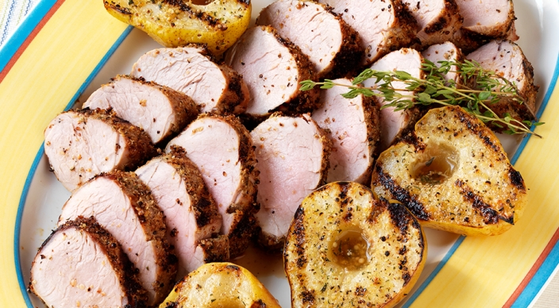
Rub
- 2 tablespoons fresh thyme leaves with tender stems
- 1 tablespoon plus 2 teaspoons yellow or black mustard seed
- 1 teaspoon kosher salt
- 1 teaspoon black peppercorns

Marinade
- 1 tablespoon Dijon mustard
- 1 tablespoon honey
- 2 teaspoons seasoned rice vinegar

Also
- 2 pork tenderloins, each ¾ to 1 pound, trimmed of excess fat and silver skin
- Extra-virgin olive oil
- 3 ripe pears, each cut lengthwise in half and cored

Instructions
- In a spice mill (or using a mortar and pestle) whirl (or pound) the rub ingredients until they are coarsely ground. Transfer the mixture to a bowl. Reserve about 4 teaspoons of the rub for the pears.
- In a medium bowl whisk the marinade ingredients. Place the pork tenderloins in a large resealable plastic bag and pour in the marinade. Press the air out of the bag and seal tightly. Turn the bag to distribute the marinade. Place on a plate and marinate at room temperature for 30 minutes.
- Prepare the grill for direct cooking over medium heat (350° to 450°F).
- Remove the pork from the bag and discard the marinade. Lightly brush the pork with oil and season evenly with the rub.
- Lightly brush the pears with oil and season the cut sides with the reserved rub.
- Brush the cooking grates clean. Grill the pork over direct medium heat, with the lid closed, until the outsides are evenly seared and the centers are barely pink, 15 to 20 minutes, turning three times. During the last 8 to 10 minutes of grilling time, grill the pears, cut side down first, over direct medium heat, until they are lightly charred and tender, turning once. Remove the pork and the pears from the grill and let the pork rest for 3 to 5 minutes. Cut the pork into ½-inch slices. Serve warm with the pears.

