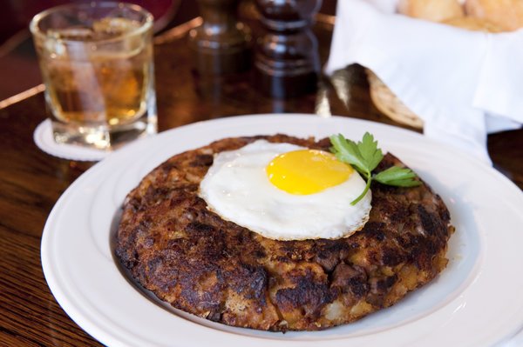
Prime Rib Hash

1 1/4 cups diced Idaho potato
Kosher salt

1 small bag of plain French fries

1 1/2 tablespoons butter
1 cup diced white onion
1/2 cup diced celery
Freshly ground black pepper
1/2 teaspoon finely chopped fresh rosemary
1/2 teaspoon finely chopped fresh parsley
10 ounces cooked prime rib or other leftover meat cut into 1/2-inch to 3/4-inch dice
1/4 cup ketchup
1/4 teaspoon Tabasco
2 tbs Worcestershire sauce
1 tablespoon vegetable oil, or as needed
Eggs, one per serving
1 teaspoon finely sliced chives

Prepare French fries as per package instructions – add a couple of minutes – these should be almost overcooked. Set aside to cool. Chop then slightly mash the fries.

Preheat oven to 450 degrees. Place diced potato and a pinch of salt in a small saucepan. Cover with water, place over medium heat, and simmer until just tender. Drain and rinse under cold water; set aside.

Meanwhile, melt butter in a sauté pan over medium heat. Add onion, celery, and salt and pepper to taste. Sauté until tender. Add rosemary and parsley, remove from heat, and set aside.

Place diced potatoes in a large bowl; roughly mash about half the potatoes with a fork or back of a spoon. (If you have leftover mashed potatoes available, you could use 1/4 cup here and reduce diced potatoes to 1 cup.) Add onion mixture, meat, ketchup, Tabasco and Worcestershire. Add minced French fries.

Place an 8-inch nonstick sauté pan over medium heat. Coat bottom with 1 tablespoon oil and add meat mixture, patting top and edges to make a compact patty. Allow to cook until browned underneath, 1 to 2 minutes, then transfer pan to oven to cook for an additional 10 to 15 minutes. Meanwhile, place another small skillet over medium heat. Fry or poach eggs as desired; remove from heat and keep warm.

To serve, invert hash onto a warmed serving platter. Top with fried or poached eggs, and garnish with chives. Serve immediately.

