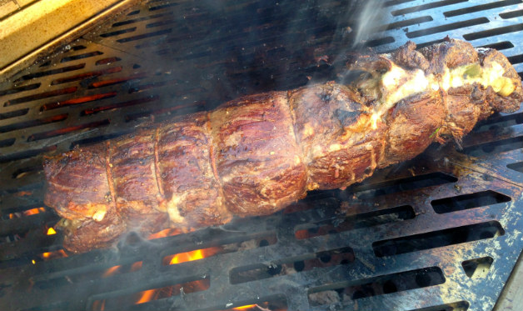
For the grilled garlic bread:
1 stick (8 tablespoons) salted butter, at room temperature
2 cloves garlic, minced
3 tablespoons minced fresh cilantro or parsley
1 loaf French bread, cut sharply on the diagonal into 1/2 inch slices

For the chipotle sauce:
1 cup mayonnaise (preferably Hellmann’s)
1 to 2 canned chipotle chiles in adobo sauce, minced with 1 tablespoon of canned adobo sauce

For the beef:
2 poblano chiles
1 large sweet onion, cut crosswise into 1/2 inch thick slices
Extra virgin olive oil
Coarse salt and freshly ground black pepper
1 beef tenderloin (4 to 5 pounds), trimmed
4 ounces thinly sliced aged provolone cheese

Step 1: Prepare the garlic bread: Place the butter, garlic, and cilantro in a mixing bowl and whisk to mix. Lightly butter each bread slice with the garlic butter and set aside.

Step 2: Make the chipotle sauce: In a small bowl, combine the mayonnaise, chipotle, and adobo sauce and stir to blend.

Step 3: Set up the grill for direct grilling and preheat to high. Ideally, you’ll be working on a wood-burning grill. Brush and oil the grill grate.

Step 4: Grill the poblanos until charred on all sides, 4 to 6 minutes per side. Transfer to a cutting board and let cool. Scrape off any burnt skin, remove the stems, and cut the chiles in half. Scrape out and discard the seeds.

Step 5: Skewer the onion slices crosswise on skewers. Brush on both sides with oil and season with salt and pepper. Grill the onions until browned on both sides, 2 to 3 minutes per side. Transfer to the cutting board, let cool, and remove the skewers.

Step 6: Make a lengthwise cut in the tenderloin (do not cut all the way through) and open it like a book. Season the meat, inside and out, with salt and pepper. Spread the inside with half of the chipotle sauce. Lay the strips of poblano end-to-end in the pocket you cut in the meat. Top with grilled onions and slices of provolone. Close the meat around the cheese and vegetables and tie at 2-inch intervals with butcher’s string. Brush the outside of the tenderloin with olive oil and season generously with salt and pepper.

Step 7: Grill the tenderloin until well-browned on the outside and cooked to taste, 4 to 5 minutes per side, 15 to 20 minutes in all for medium-rare (about 135 degrees). Transfer the beef to a cutting board and let rest for a couple of minutes. Remove the string, then cut the tenderloin crosswise into 1/2 inch thick slices.

Step 8: Meanwhile, grill the garlic bread until browned on both sides, about 1 to 2 minutes per side.

Step 9: To serve, spread the garlic bread with the remaining chipotle sauce. Top with grilled beef and serve as an open-faced sandwich.

