Skirt Steaks with Red Chile Sauce
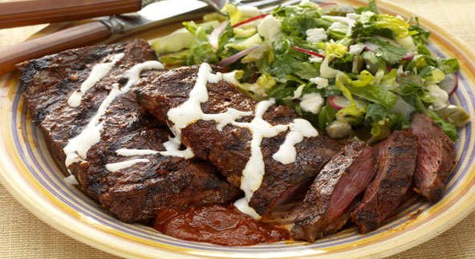
Ingredients
4 large dried guajillo or New Mexico chiles, 1 to 1-1/4 ounces total, stemmed and seeded

Salad
6 cups thinly sliced romaine lettuce
1 cup thinly sliced radishes
1 cup loosely packed fresh cilantro leaves
1 cup thinly sliced red onion
1/4 cup sliced, pickled jalapeño chile peppers (from a jar), roughly chopped, plus 1/4 cup of the pickling liquid for the dressing
5 ounces coarsely crumbled feta cheese (about 1 cup)

Dressing
6 tablespoons sour cream or crema mexicana
5 tablespoons mayonnaise
Freshly ground black pepper
Vegetable oil
1 teaspoon ground cumin
Kosher salt
2 pounds skirt steak, 1/4 to 1/2 inch thick, trimmed of excess surface fat, cut crosswise into 6-inch pieces

Instructions
In a medium saucepan combine the dried chiles with enough cold water to cover them generously. Bring to boil and then reduce the heat to medium-low. Cover and simmer until the chiles are very soft, 30 to 40 minutes.

While the chiles are simmering, make the salad: In a large bowl combine the romaine, radishes, cilantro, onion, and pickled jalapeños (without their liquid). Sprinkle the feta on top. Cover and refrigerate.
In a small bowl whisk the sour cream, mayonnaise, and 1/4 cup reserved pickling liquid. Season with 1/4 teaspoon pepper, cover, and refrigerate.

When the chiles are very soft, finish making the sauce: Lift the chiles from the saucepan and put them into a small food processor, reserving the simmering liquid. Add 1/4 cup of the simmering liquid and 3 tablespoons oil to the food processor. Puree until smooth, 3 to 5 minutes. If the chile puree isn’t smooth after 5 minutes, strain the mixture through a fine mesh strainer, pressing on the solids to extract as much puree as possible. Discard the solids in the strainer. Season the puree with the cumin, 1/4 teaspoon salt, and 1/4 teaspoon pepper. Transfer 3 tablespoons of the chile puree to a small bowl and set aside for serving.

Pat the steaks dry with paper towels and place them in a 13-by-9-inch glass baking dish. Coat the steaks on both sides with 1 tablespoon oil. Pour the remaining chile puree over the steaks and turn to coat. Season the steaks evenly with salt and pepper. Let the steaks marinate at room temperature for 20 to 30 minutes.

Prepare the grill for direct cooking over high heat (450° to 550°F).

Brush the cooking grates clean. Grill the steaks over direct high heat, with the lid closed, until cooked to your desired doneness, 4 to 6 minutes for medium rare, turning once or twice. Remove the steaks from the grill and tent with foil to keep warm.

Divide the salad among serving plates. Place the steak alongside the salad and spoon the reserved chile sauce next to the steaks. Drizzle the dressing over the steak and salad and serve immediately.

