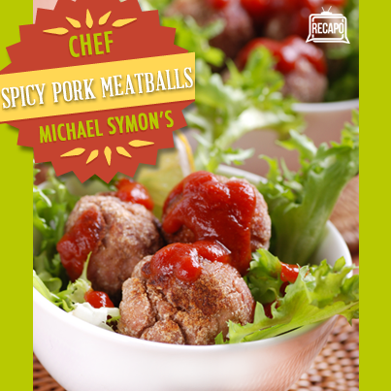
1 English Cucumber (quartered lengthwise)
4 sliced Radishes
1/4 cup torn Mint Leaves
1/2 cup shredded Carrot
1/4 cup picked Cilantro leaves
1 head Bibb Lettuce leaves
1 sliced Jalapeno
1 Lime, wedged
1/2 recipe Spicy Pork Meatballs (see below)

Spicy Pork Meatballs Ingredients
1/2 cup Day Old Bread, torn (crusts removed)
1 lb Ground Pork
1/2 cup minced Onion
2 cloves minced Garlic
1/2 cup Whole Milk
1 seeded, minced Jalapeno
1/2 tsp Coriander
Zest of 1 Orange
1 tsp Fish Sauce or chopped Anchovies (optional)
Flour
Vegetable or Canola Oil (don’t use Olive Oil this time!)
Salt & Pepper
Directions
Soak bread in milk for meatballs. Combine remaining meatball ingredients in a large bowl. Season meat to taste with salt and pepper. Wring excess milk from bread and mix into meatballs. Mix in remaining meatball ingredients and form into balls no larger than a golf ball.

Heat a saute pan to medium high. Add canola oil to the pan for frying, filling about 1/3 of the pan. Dredge meatballs in flour to coat. Shake off excess flour. Brown meatballs thoroughly, cooking about five minutes. (Optionally, stick them in the oven at 325 for a few minutes to finish cooking.)

Let cooked meatballs rest on a paper towel-lined plate before assembling lettuce cups. Using larger outer lettuce leaves, place a couple meatballs in each leaf. Assemble by adding cucumber, radish, mint, cilantro, carrot, and jalapeno. Squeeze fresh lime juice over the lettuce cup before tasting.

