Spanish-Style
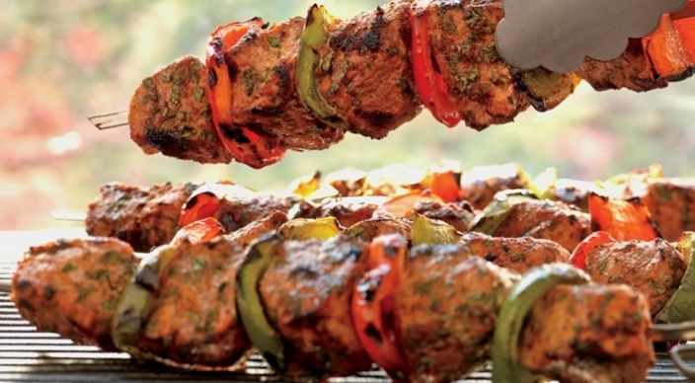
Pork
Kebabs

Marinade
- ⅓ cup finely chopped fresh
Italian parsley leaves and tender stems
- ¼ cup extra-virgin olive oil
- 2 tablespoons minced red onion
- 1 tablespoon sherry vinegar
- 1 tablespoon smoked paprika
- 2 teaspoons ground cumin
- 2 teaspoons minced garlic
- ¼ teaspoon ground cayenne pepper

- Kosher salt
- 2 pork tenderloins, each about 1 pound, trimmed of silver skin and any excess fat, cut into 1¼-inch cubes
- 3 large bell peppers, 1 red, 1 yellow, and 1 green, cut into 1¼-inch squares

- Whisk the marinade ingredients, including ½ teaspoon salt. Put the pork cubes in a large, resealable plastic bag and pour in the marinade. Press the air out of the bag and seal tightly. Turn the bag to distribute the marinade, place in a bowl, and refrigerate for 4 to 8 hours, turning occasionally.
- If using bamboo skewers, soak in water for at least 30 minutes.
- Prepare the grill for direct cooking over high heat (450° to 550°F).
- Remove the pork from the bag and discard the marinade. Thread the pork and bell pepper squares alternately onto skewers.
- Brush the cooking grates clean. Grill the skewers over direct high heat, with the lid closed as much as possible, until the pork is barely pink in the center, 8 to 10 minutes, turning once or twice. Remove from the grill and season with salt. Serve warm.

